Tutorial 1  
10. Second Sample Application - Create an online grocery  
1. Creating the navigation drawer  
  
go to chrome and search design support library



com.android.support:design:28.0.0

ei code ta coppykoreniyegradle scripts🡪build gradle(module:app) e bosabo



buildToolsVersion**"29.0.2" eta hobarkarone ,**com.android.support:design:28.0.0erbodoleimplementation **'com.android.support:design:29.0.2' dieyechi**

navigation header create korbo:





Xml file ta design korbo:



Pixabay theke ekta icon download korechi

Seta drwable e paste korechi

Image view er src e teoi mage ta bosiyechi

Picture borohoyejaoai height & width dui ta e 70dp korediyechi



Item gulo navigation drawer e save korarjonno:







Menu resource fileernamdibonavigation_drawer_menu



Click clip art







Custom color ta black korechi

Evabebaki icon gulo o add korenibo (category, about us, terms, licenceserjonno)

Navigation_drawer_menu_xmler code likhbo





Toolbar use korte min sdk version 21 lage



Ekhon toolbar & action bar add korbo



In your Activity.java import android.support.v7.widget.Toolbar instead of android.widget.Toolba





Drawer open, drawer close eruporalt+enterchepe first option tai enter dibo, same namdiye ok dibo



Run the app

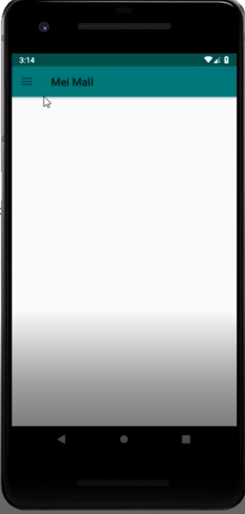

Left side er corner e tin ta dag show korche  
jetai chap dile navigation drawer open hobe

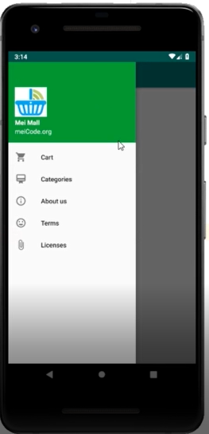

Task done



Ei line tar uporalt+entchepeprothom option tai click korleekta override method ashbe











Name it fragment_main





Name it MainFragment



Generate🡪override method e giye oncreateview click korbo



Run the app

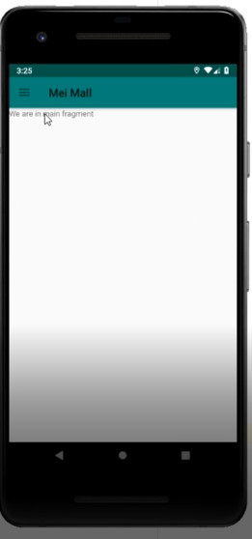

First page tai showkorche we are in main fragment

done

Tutorial 1  
10. Second Sample Application - Create an online grocery  
2. Bottom navigation view - shared preferences





Icon gulo drawable e set koreniyechi











Run the app

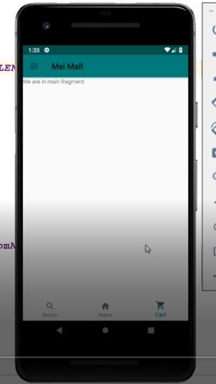

Niche dekhtsi search ,home, cart er ghor chole ashche

done

Run korar por dekhtsi home auto select hoye ache, eta default korbo



Run the app

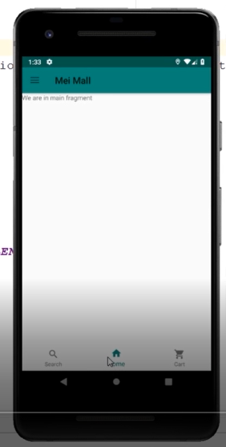

Ebar dekhbo home button auto select hoye ache

done



Ekta package nibojetai sob model gulorakhbo





Model package e r ekta class nibo Review















Percable e alt+entchapbo





Review tealt+entchapbo













Utils namer r ekta java class nibo

















Parcelable e alt+enterkorbo



groceryItem e alt+entchapbo





Ei line gula project e use kroenai  
just bujhaise









Psfsmane **public static final** String

Json library import korbo

<https://github.com/google/gson>











Run the app

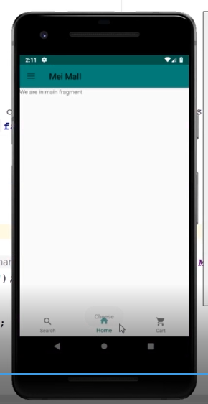

Home er upor cheese show korche

done

Tutorial 1  
10. Second Sample Application - Create an online grocery  
3. Initialize shared preferences and recycler view adapter

Selected ongso ta delete kroedibo



Selected ongso ta delete koredilam











ArrayList<GroceryItem>allItems = **new** ArrayList<>();  
allItems.add(**new** GroceryItem(**"cheese"**,**"Best cheese possible"**,  
**"http://cdn.shopify.com/s/files/1/0150/0232/products/Pearl_Valley_Swiss_Slices_36762caf-0757-45d2-91f0-424bcacc9892_grande.jpg?v=1534871055"**,  
**"food"**, 3, 4.45));  
allItems.add(**new** GroceryItem(**"Cucumber"**,**"Best Cucumber possible"**,  
**"https://encrypted-tbn0.gstatic.com/images?q=tbn:ANd9GcTapdZPL-NqqJaAr_wvW6LueDwcGZhoCHmG8dmiLZffhIcsUyFN&s"**,  
**"food"**, 7, 9.4));  
allItems.add(**new** GroceryItem(**"Coca Cola"**,**"Tasty"**,  
**"https://img.etimg.com/thumb/width-640,height-480,imgsize-412854,resizemode-1,msid-71812767/coca-cola-set-to-sell-some-bottling-units-to-partners.jpg"**,  
**"food"**, 8, 7.56));  
allItems.add(**new** GroceryItem(**"Spaghetti"**,**"Best Spaghetti possible"**,  
**"https://www.fivehearthome.com/wp-content/uploads/2019/03/One-Pot-Spaghetti-Recipe-by-Five-Heart-Home_700pxPlate.jpg"**,  
**"food"**, 30, 4.95));  
allItems.add(**new** GroceryItem(**"ChikenNugget"**,**"BestChiken Nugget possible"**,  
**"https://media.npr.org/assets/img/2017/05/09/10-piece-chicken-nuggets-ss_0_custom-db31f599b4b36050d9a26986abaf75c76c655f37-s800-c85.jpg"**,  
**"food"**, 56, 43.45));  
allItems.add(**new** GroceryItem(**"Clear Shampoo"**,**"Good Product"**,  
**"https://domreii.com/pub/media/catalog/product/cache/c687aa7517cf01e65c009f6943c2b1e9/5/a/5ae29e21nd298d8d9.jpg"**,  
**"Usable Product"**, 300, 79));  
allItems.add(**new** GroceryItem(**"Axe Body Spray"**,**"Good Product"**,  
**"https://encrypted-tbn0.gstatic.com/images?q=tbn:ANd9GcQVeix3yPPYull7SYmkASN3wmHhCsbLdKec61eGXdrLTmDHS_dO&s"**,  
**"Usable Product"**, 98, 90));  
allItems.add(**new** GroceryItem(**"Kleenex"**,**"Good Product"**,  
**"https://www.kleenex.com.gwstest.net/-/media/images/kleenex/products-new/anti-viral/boxes-upright/antiviralgreen.png?h=365&w=424&la=en-US&hash=BFC4457B88C931E5A91BEE678ECE900A36796C0E"**,  
**"Usable Product"**, 89, 43));  
allItems.add(**new** GroceryItem(**"Face Wash"**,**"Good Product"**,  
**"https://ntg-catalog.imgix.net/products/NTG_70501028209_30034003_Oil_Free_Acne_Wash_Daily_Scrub_4.2oz_00000.jpg?w=1200&h=1443&sfrm=jpg&fit=crop"**,  
**"Usable Product"**, 92, 9.45));  
  
  
String finalString =gson.toJson(allItems);  
editor.putString(**"allItems"**,finalString);  
editor.apply();

Etotukuongshoketefelbo



Init all items er upor alt+ent chapbo





Cut kora code ta eijaigai paste korbo





Copy this line



And paste this line below init all items started





Delete this line

Gson, sharedpreference e error dekhacchilo, alt+entchepe reuse diyechi



Module app e recyclerview, cardview,glide add korbo



*//recycler view*implementation **'com.android.support:recyclerview-v7:29.0.2'***//card view*implementation **'com.android.support:cardview-v7:29.0.2'***//glide*implementation **'com.github.bumptech.glide:glide:4.9.0'**annotationProcessor**'com.github.bumptech.glide:compiler:4.9.0'**

Layout-new-layout resource file- grocery_rec_view_list_item



*<?***xml version="1.0" encoding="utf-8"***?>*<**androidx.cardview.widget.CardViewxmlns:android="http://schemas.android.com/apk/res/android"  
xmlns:app="http://schemas.android.com/apk/res-auto"  
android:id="@+id/parent"  
android:layout_width="160dp"  
android:layout_height="160dp"  
android:layout_margin="5dp"  
android:padding="7dp"  
app:cardElevation="2dp"**>  
<**RelativeLayout  
android:layout_width="wrap_content"  
android:layout_height="wrap_content"**>  
<**ImageView  
android:id="@+id/itemImage"  
android:layout_width="match_parent"  
android:layout_height="match_parent"  
android:layout_marginBottom="20dp"  
android:src="@drawable/ic_launcher_background"**>  
</**ImageView**>  
<**TextView  
android:id="@+id/txtPrice"  
android:layout_width="wrap_content"  
android:layout_height="wrap_content"  
android:layout_alignParentTop="true"  
android:layout_alignParentRight="true"  
android:layout_marginTop="10dp"  
android:layout_marginRight="10dp"  
android:background="@color/colorAccent"  
android:text="price"  
android:textColor="#FFF"  
android:textStyle="bold"**>  
</**TextView**>  
<**TextView  
android:id="@+id/txtItemName"  
android:layout_width="wrap_content"  
android:layout_height="wrap_content"  
android:layout_alignParentBottom="true"  
android:layout_centerHorizontal="true"  
android:text="name"  
android:textSize="16sp"  
android:textStyle="bold"**>  
</**TextView**>  
</**RelativeLayout**>  
</**androidx.cardview.widget.CardView**>

Notunekta java class niboGroceryItemAdapter





Eijaigai right button-generate-constructor





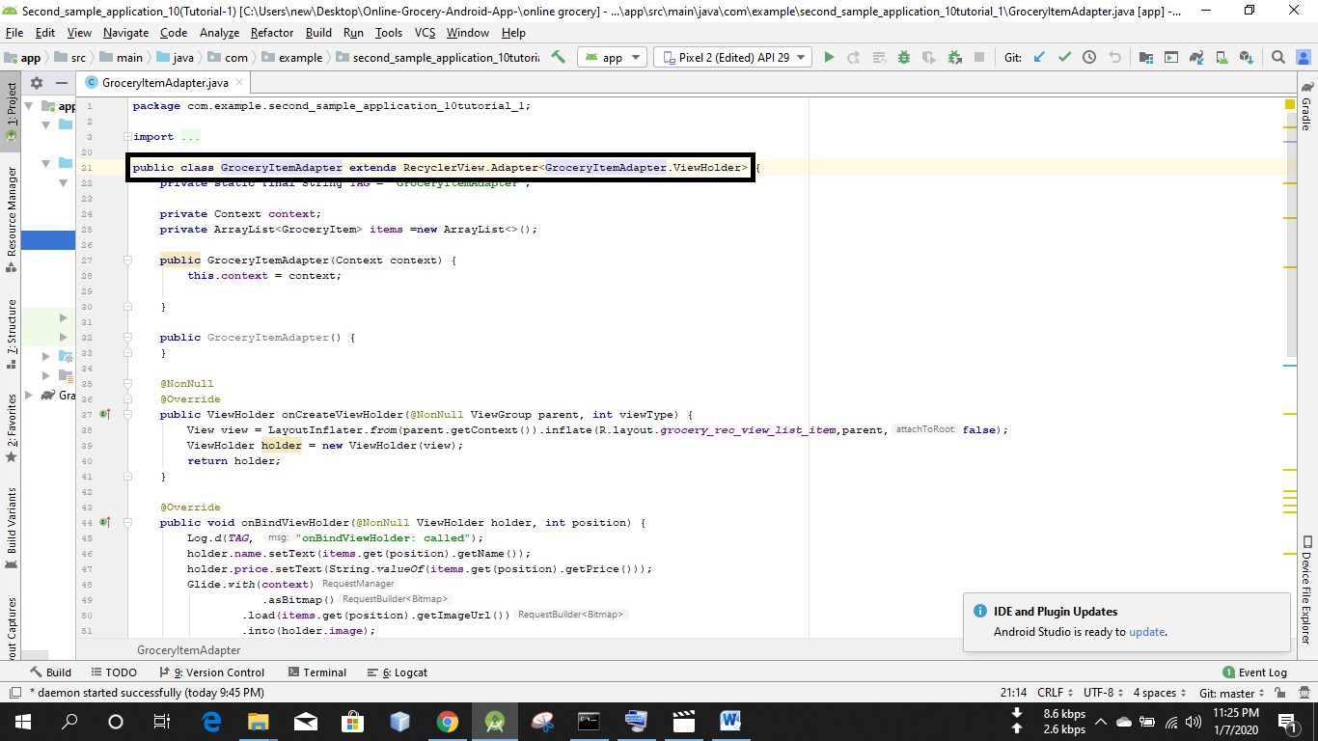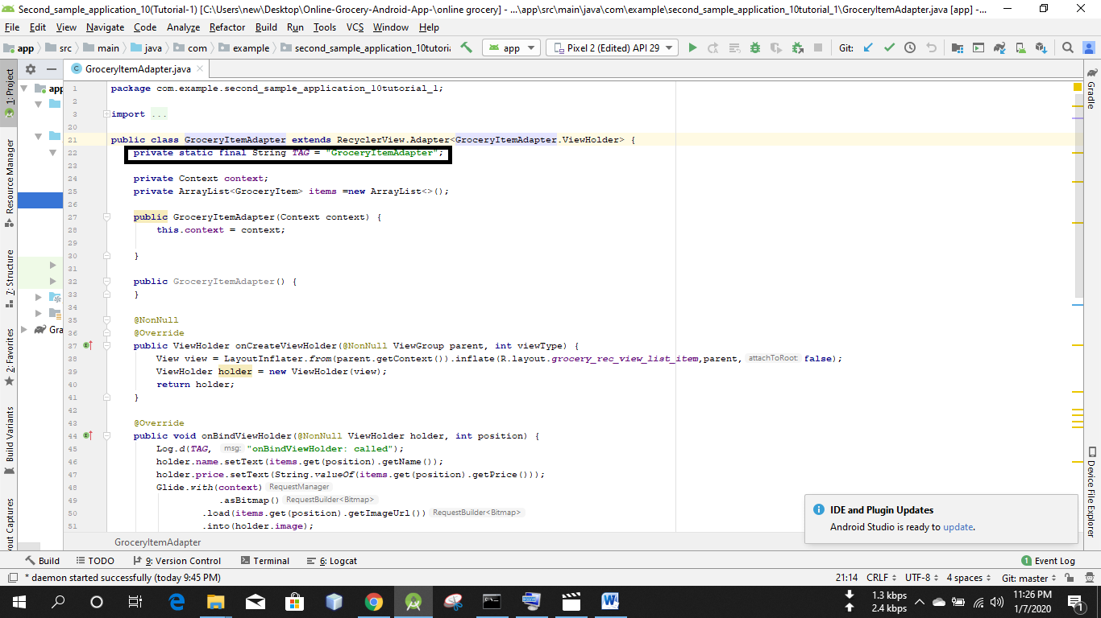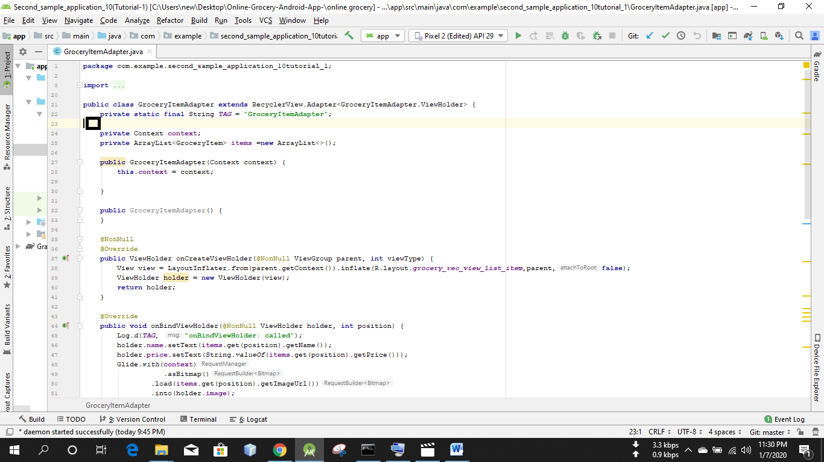

Apply korbo imple mentor method gulo

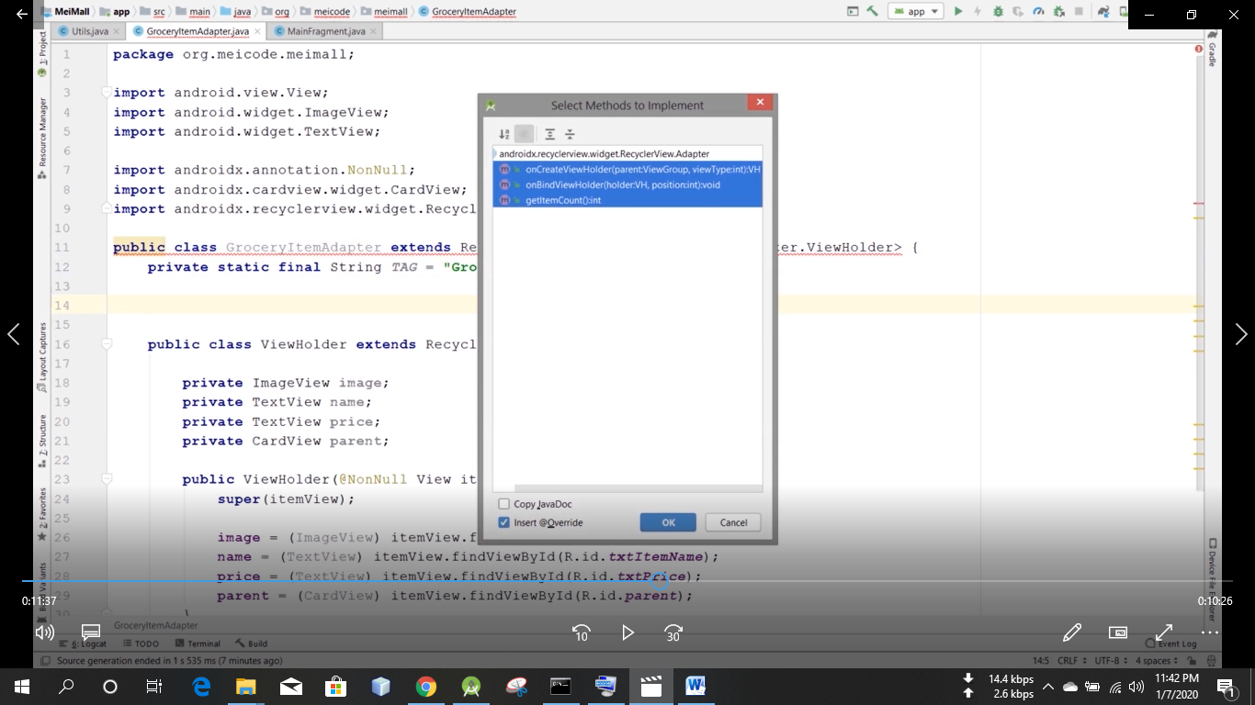

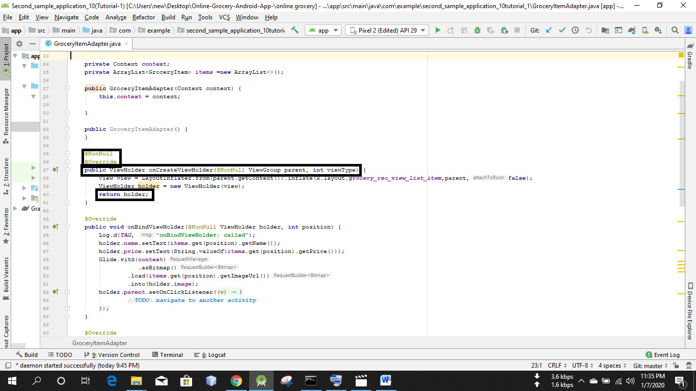

Dagano line gulo ashbe  
but return holder na , return null ashbe

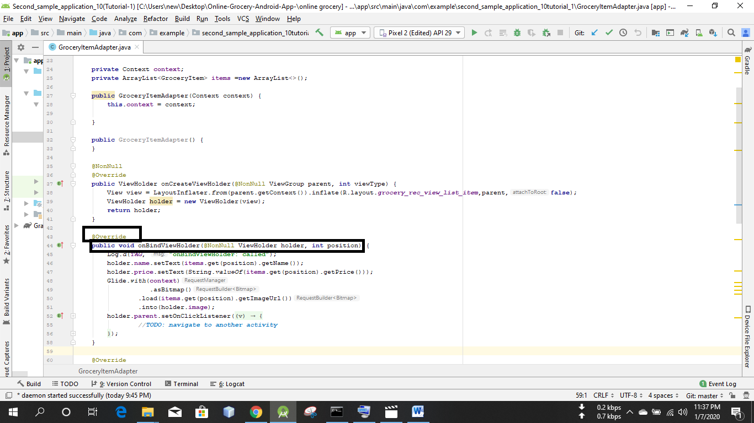

Ei dagano line gulo ashbe

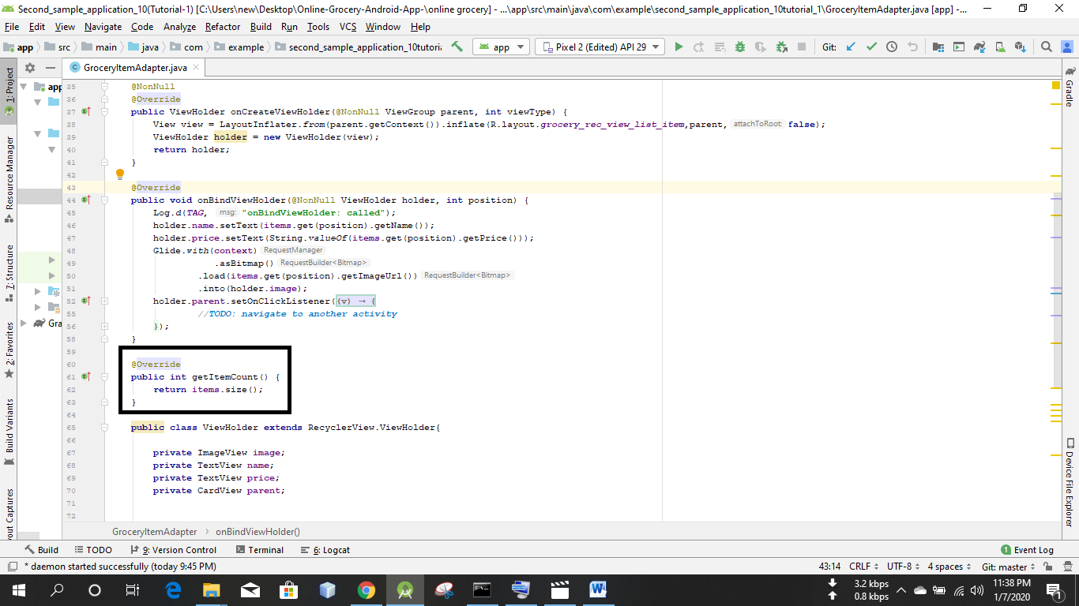

Ei dagano line gulo ashbe  
but return item size() er jaigai return 0 ashbe



Ei jaigai constructor generatekorbo

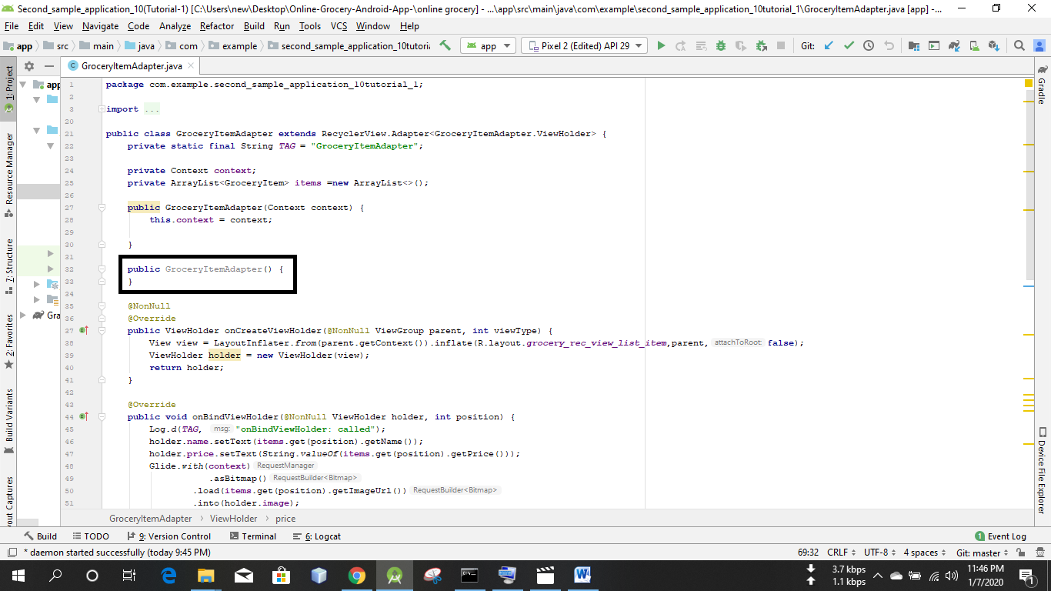

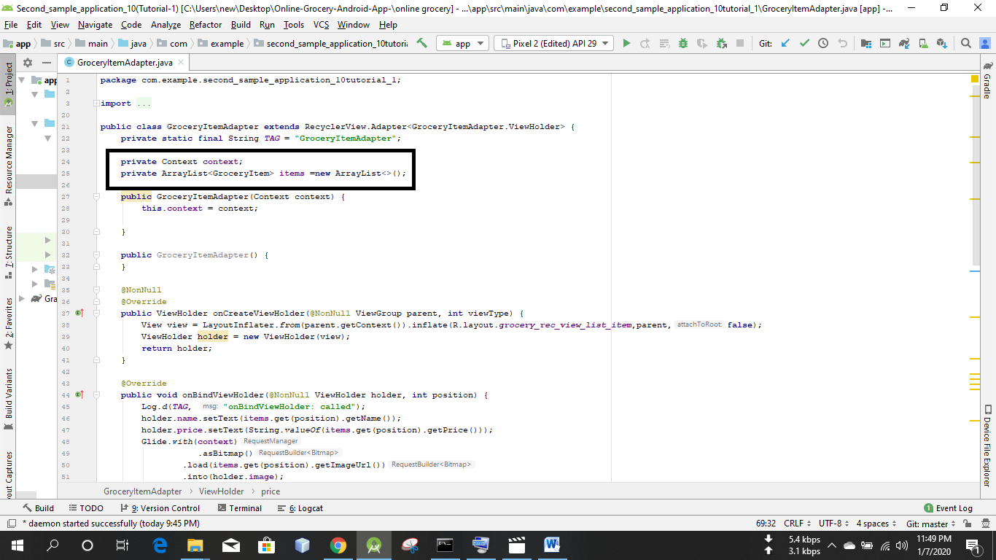

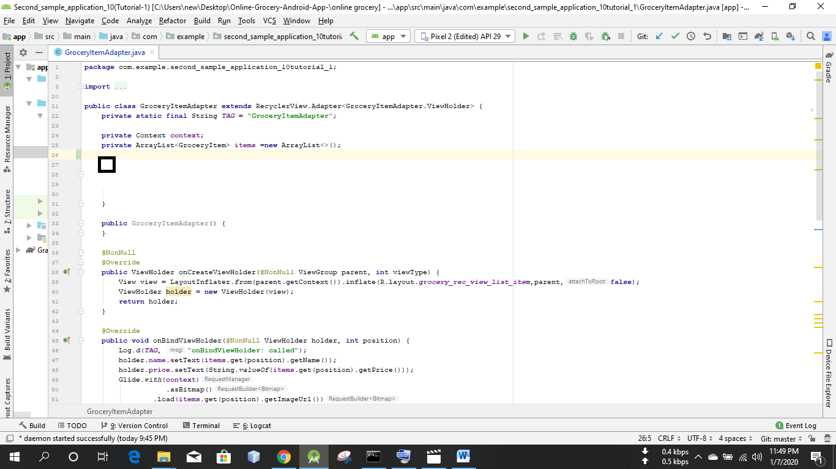

Ei jaigai constructor generate korbo

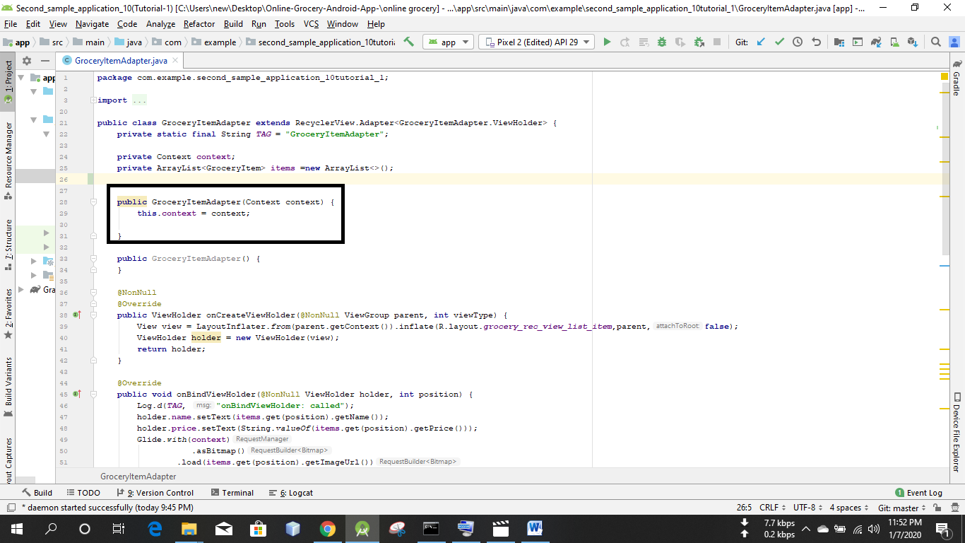

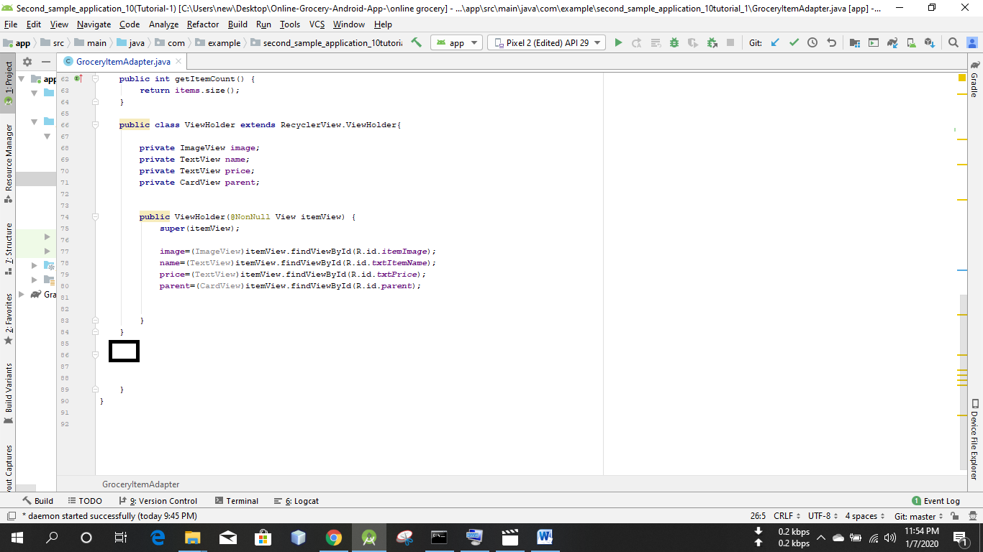

I put here setter method only for grocery item

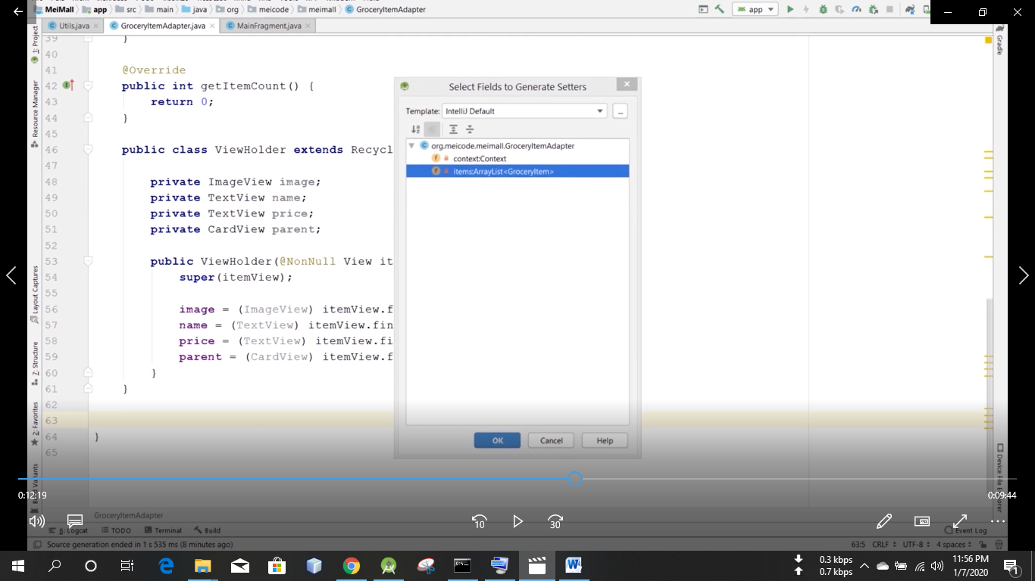

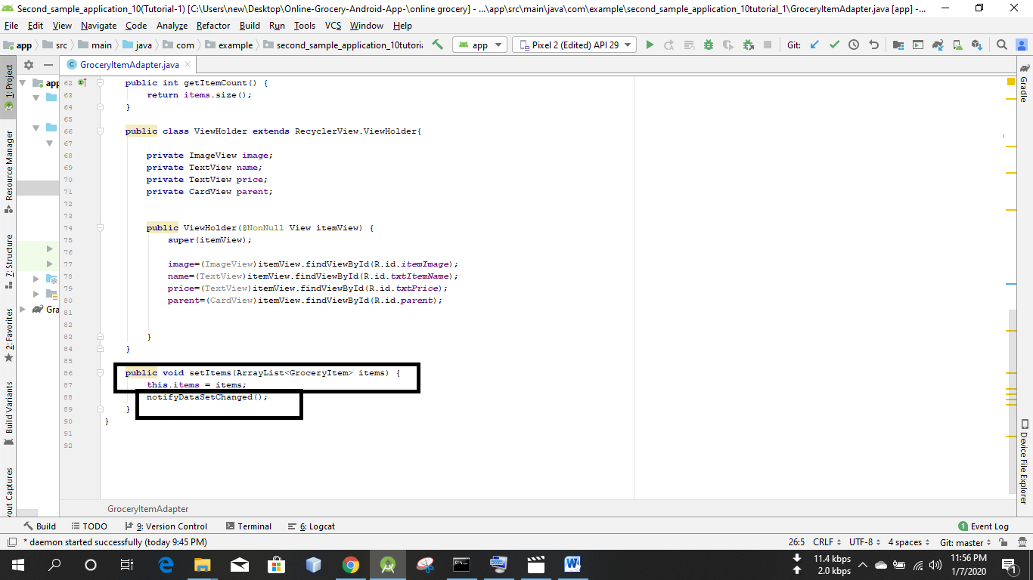

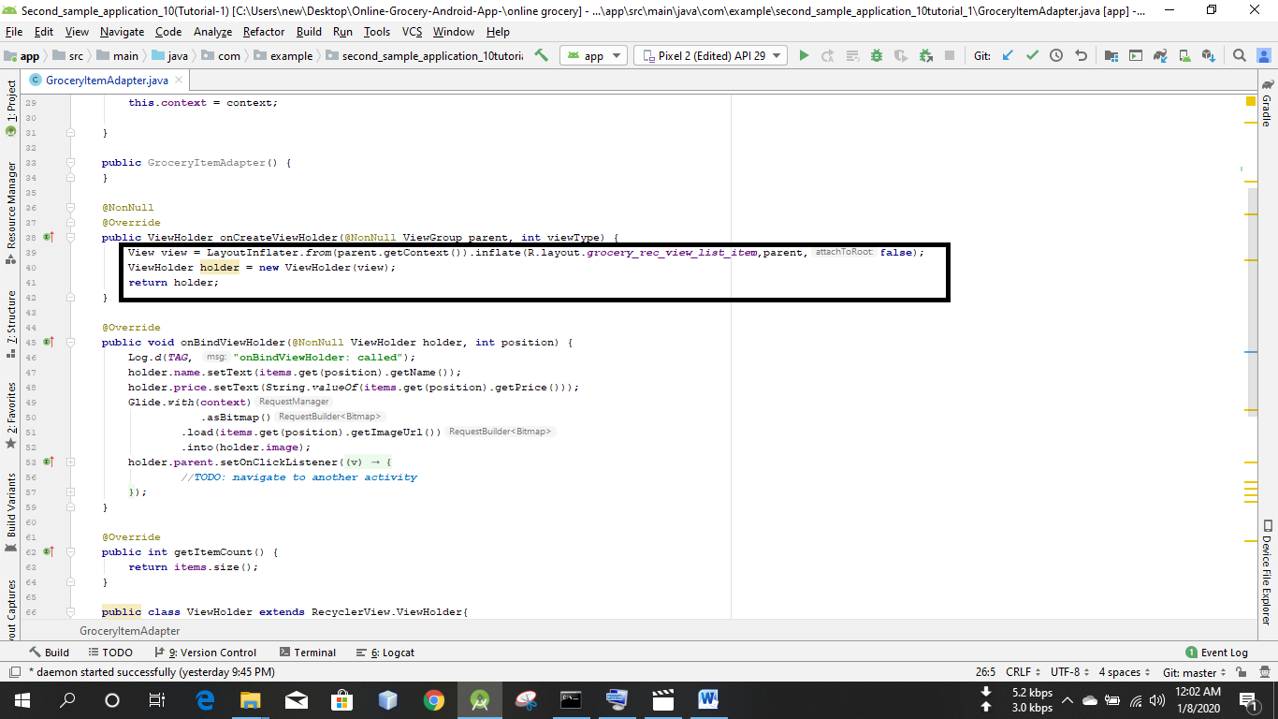

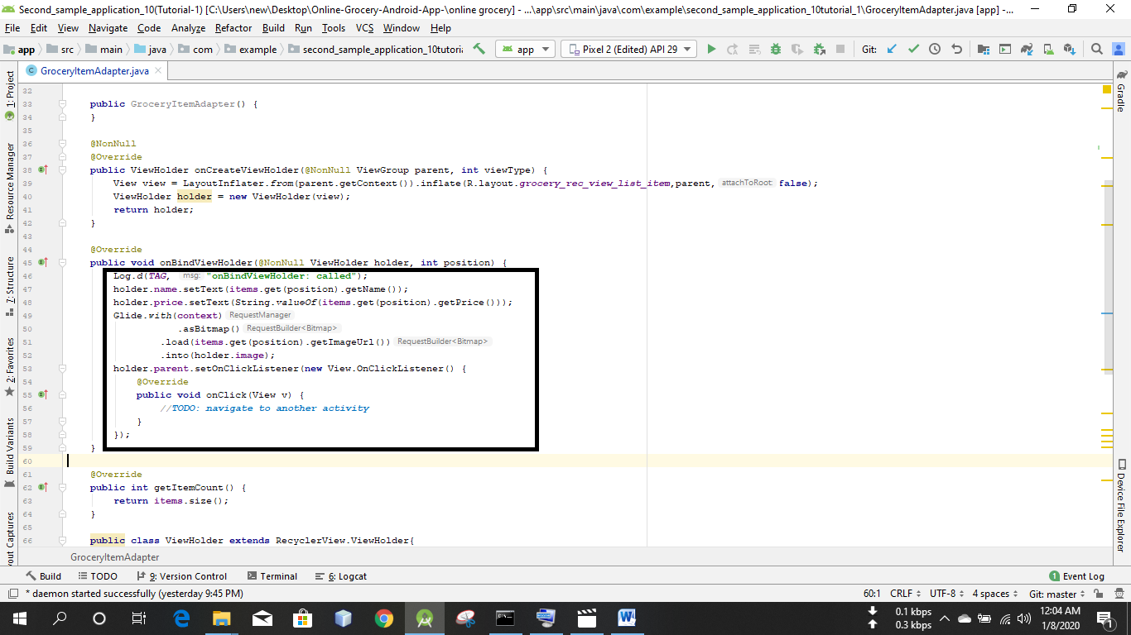

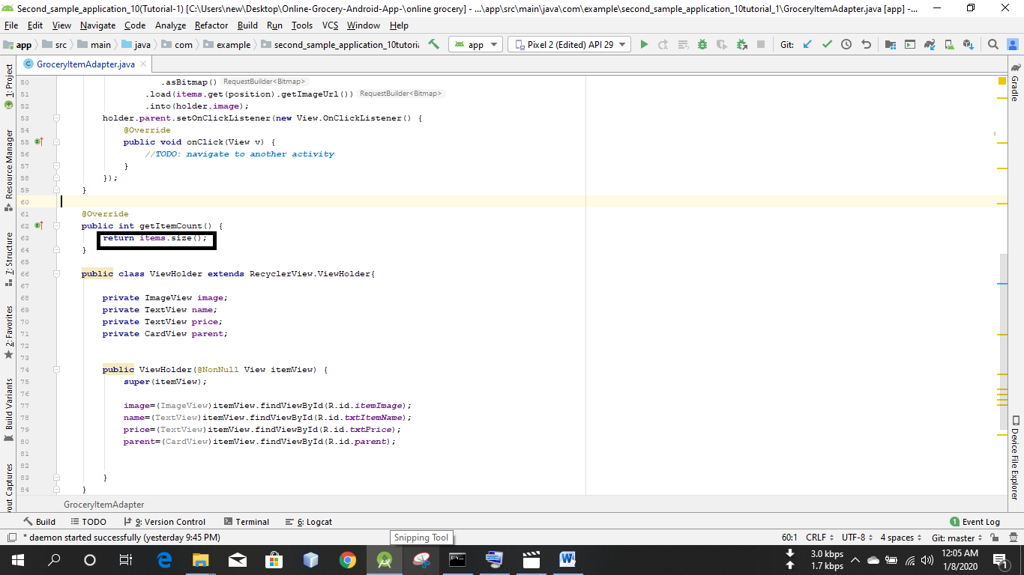

Fragment_main.xml nam eekta layout design kore nibo

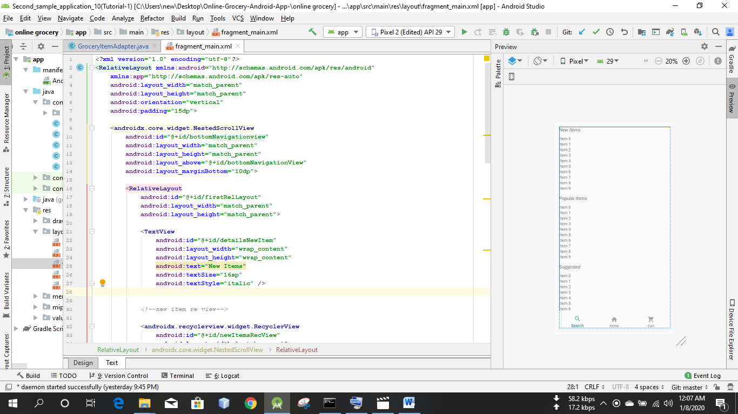

*<?***xml version="1.0" encoding="utf-8"***?>*<**RelativeLayout xmlns:android="http://schemas.android.com/apk/res/android"  
 xmlns:app="http://schemas.android.com/apk/res-auto"  
 android:layout_width="match_parent"  
 android:layout_height="match_parent"  
 android:orientation="vertical"  
 android:padding="15dp"**>  
  
 <**androidx.core.widget.NestedScrollView  
 android:id="@+id/bottomNavigationview"  
 android:layout_width="match_parent"  
 android:layout_height="match_parent"  
 android:layout_above="@+id/bottomNavigationView"  
 android:layout_marginBottom="10dp"**>  
  
 <**RelativeLayout  
 android:id="@+id/firstRelLayout"  
 android:layout_width="match_parent"  
 android:layout_height="match_parent"**>  
  
 <**TextView  
 android:id="@+id/detailsNewItem"  
 android:layout_width="wrap_content"  
 android:layout_height="wrap_content"  
 android:text="New Items"  
 android:textSize="16sp"  
 android:textStyle="italic"** />  
  
  
 *<!--new item re view-->* <**androidx.recyclerview.widget.RecyclerView  
 android:id="@+id/newItemsRecView"  
 android:layout_width="match_parent"  
 android:layout_height="wrap_content"  
 android:layout_below="@+id/detailsNewItem"  
 android:layout_marginTop="10dp"** />  
  
  
 <**TextView  
 android:id="@+id/detailsPopular"  
 android:layout_width="wrap_content"  
 android:layout_height="wrap_content"  
 android:layout_below="@+id/newItemsRecView"  
 android:layout_marginTop="15dp"  
 android:text="Popular Items"  
 android:textSize="16sp"  
 android:textStyle="italic"** />  
  
 <**androidx.recyclerview.widget.RecyclerView  
 android:id="@+id/PopularItems"  
 android:layout_width="match_parent"  
 android:layout_height="wrap_content"  
 android:layout_below="@+id/detailsPopular"  
 android:layout_marginTop="10dp"** />  
  
 <**TextView  
 android:id="@+id/detailsSuggested"  
 android:layout_width="wrap_content"  
 android:layout_height="wrap_content"  
 android:layout_below="@+id/PopularItems"  
 android:layout_marginTop="15dp"  
 android:text="Suggested"  
 android:textSize="16sp"  
 android:textStyle="italic"** />  
  
 <**androidx.recyclerview.widget.RecyclerView  
 android:id="@+id/SugestedItems"  
 android:layout_width="match_parent"  
 android:layout_height="wrap_content"  
 android:layout_below="@+id/detailsSuggested"  
 android:layout_marginTop="10dp"** />  
 </**RelativeLayout**>  
  
  
 </**androidx.core.widget.NestedScrollView**>  
  
  
 <**com.google.android.material.bottomnavigation.BottomNavigationView  
 android:id="@+id/bottomNavigationView"  
 android:layout_width="match_parent"  
 android:layout_height="wrap_content"  
 android:layout_alignParentBottom="true"  
 app:menu="@menu/bottom_nav_menu"**>  
  
 </**com.google.android.material.bottomnavigation.BottomNavigationView**>  
  
</**RelativeLayout**>

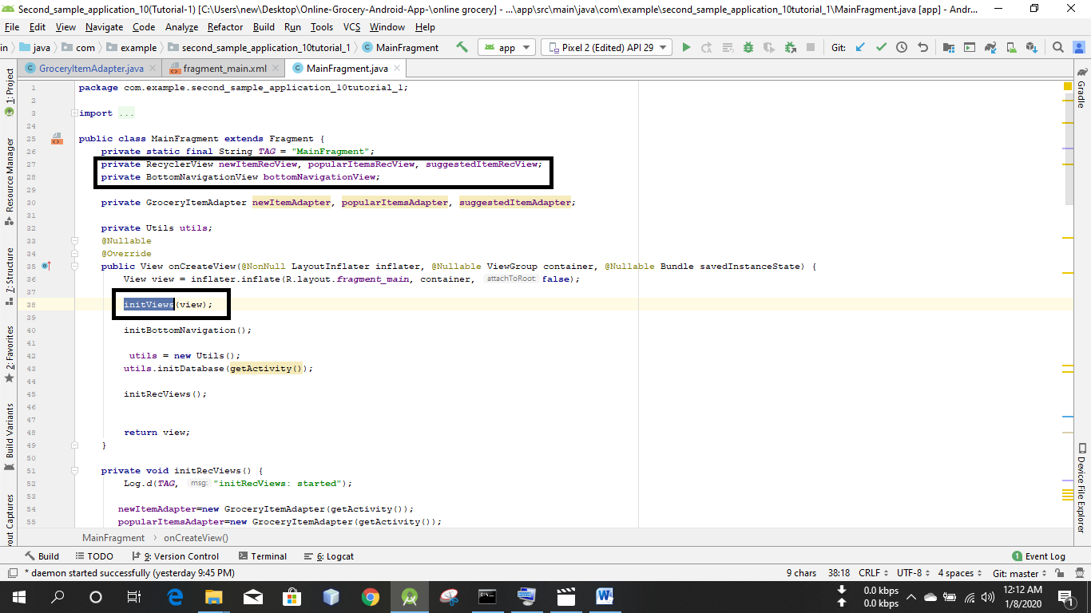

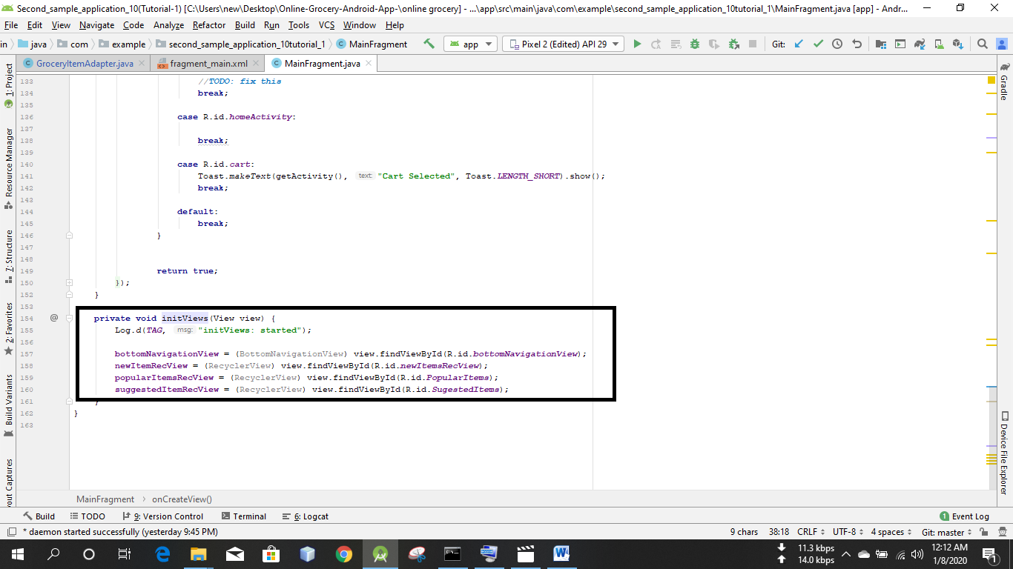

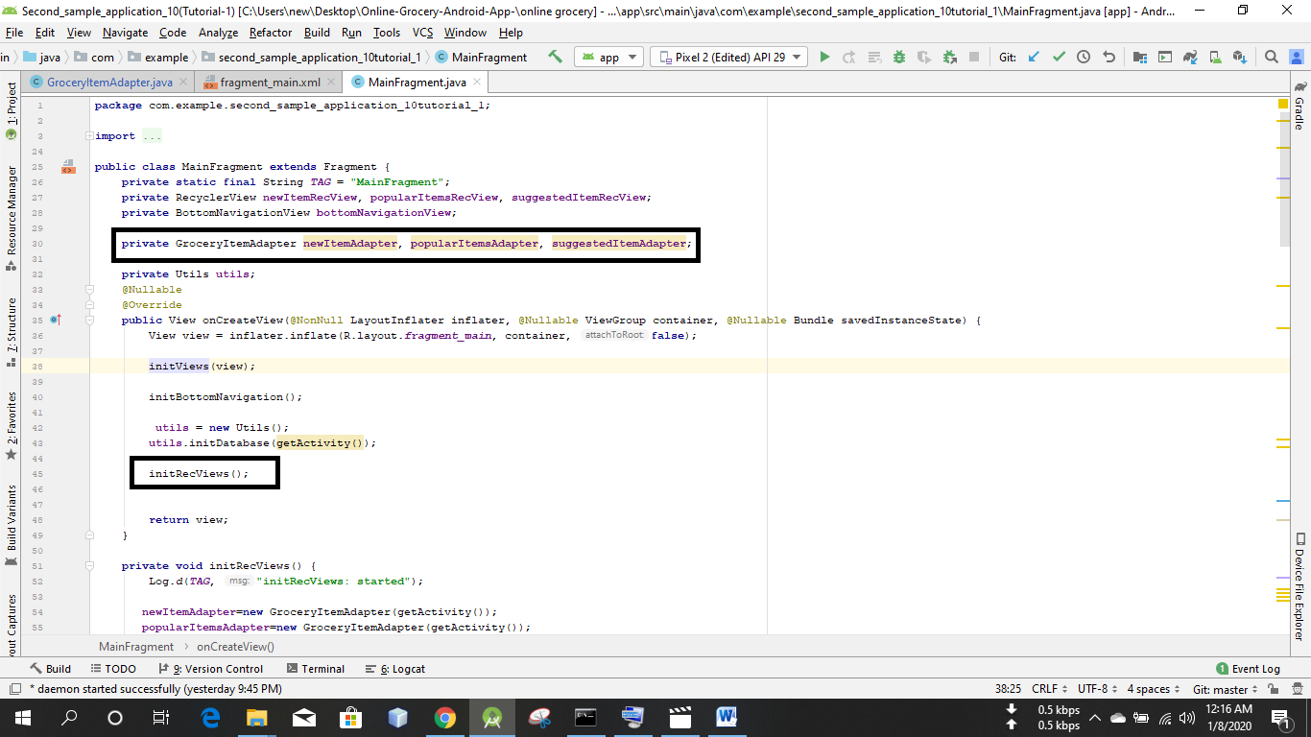

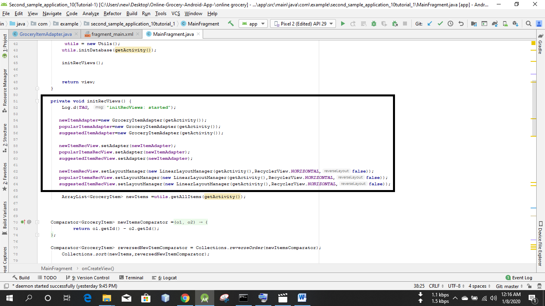

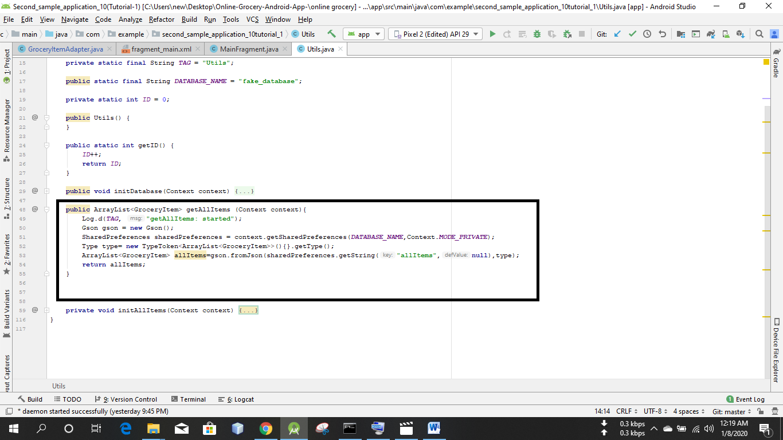

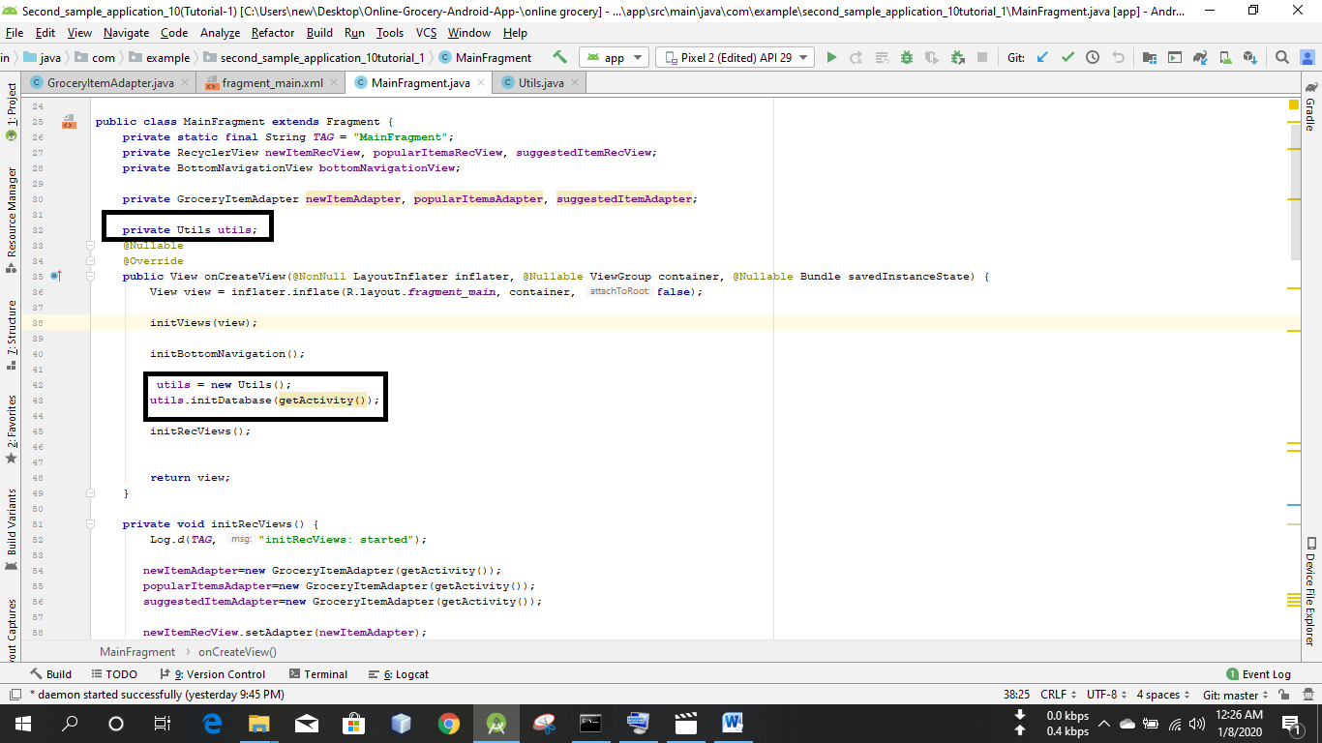

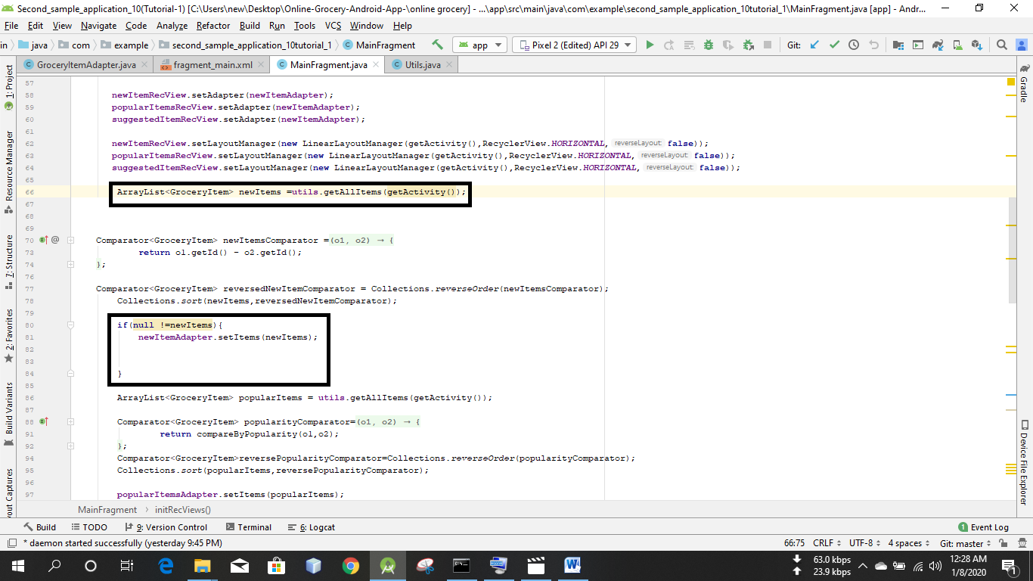

Newitems er jaigai allItems likha thakbe

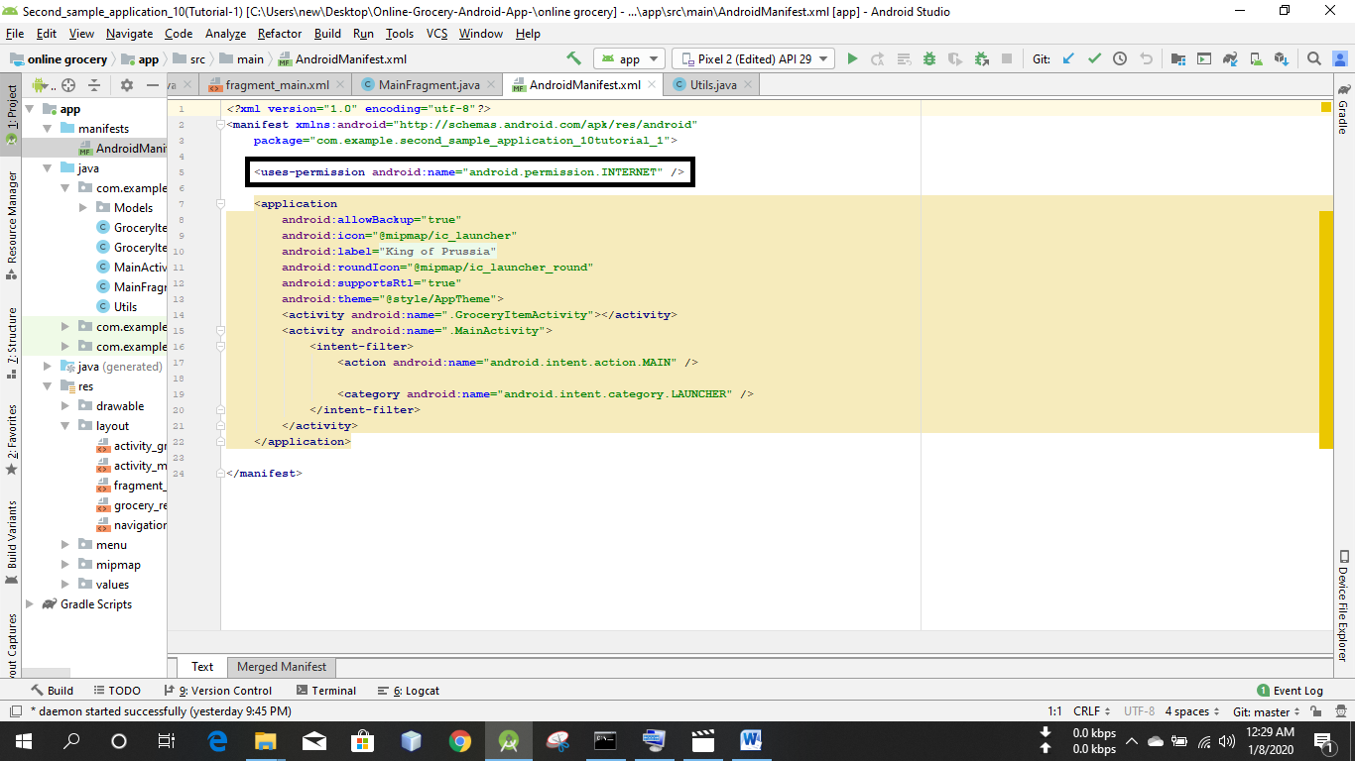

Run the app

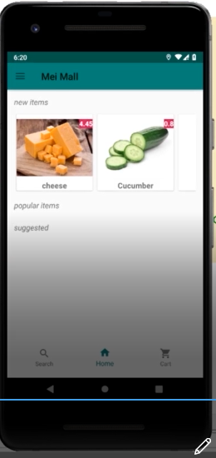

New items er pic gula bam theke dan e sundor vabe scroll korte parbo  
mane recycle view ta thik moto kaj korche

done

Tutorial 1  
10. Second Sample Application - Create an online grocery  
4. Create grocery item activity layout

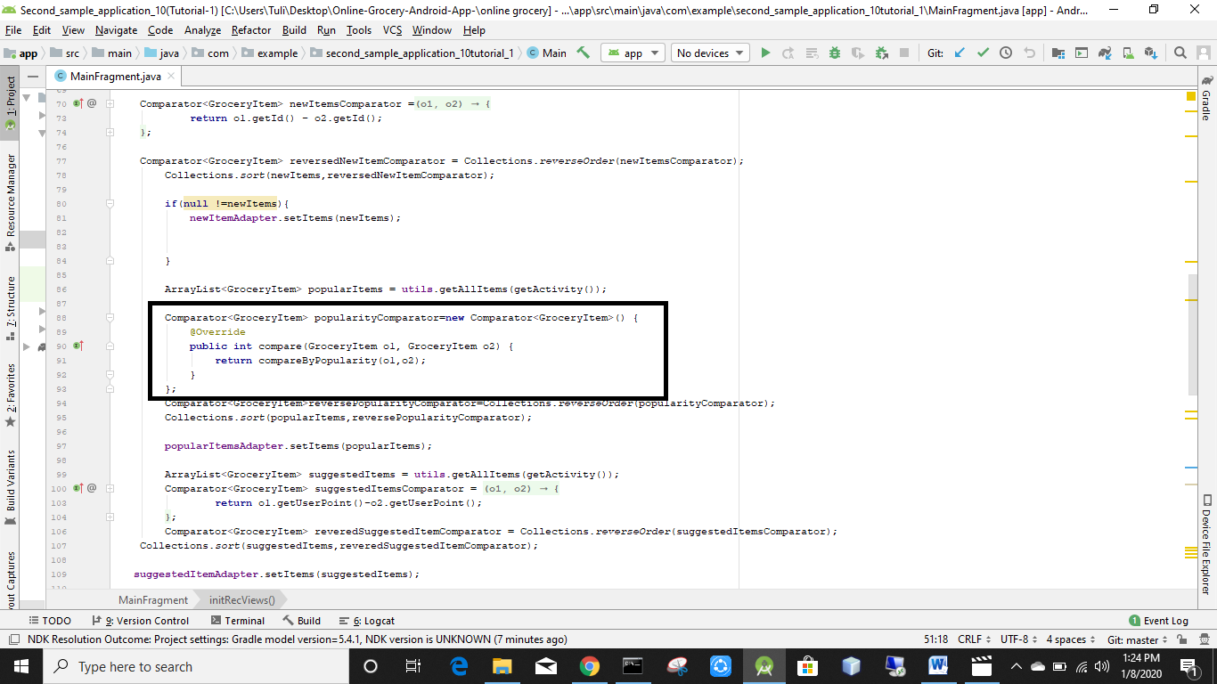

Return 0 hobe

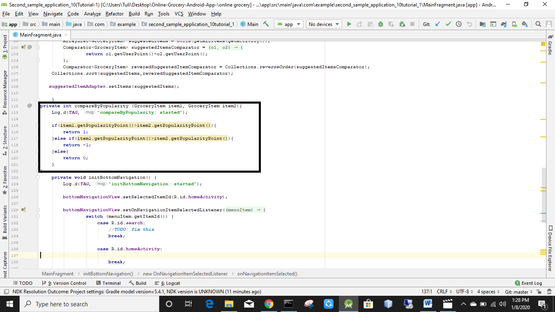

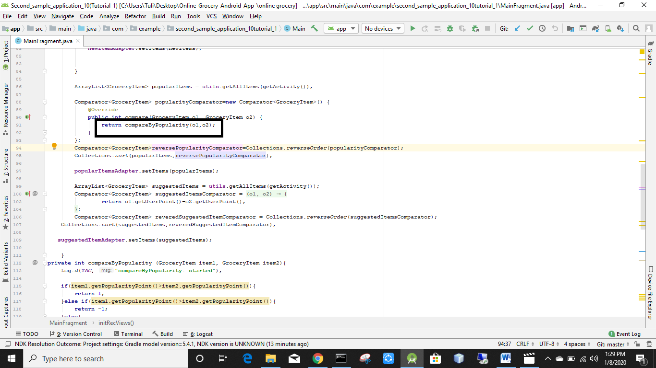

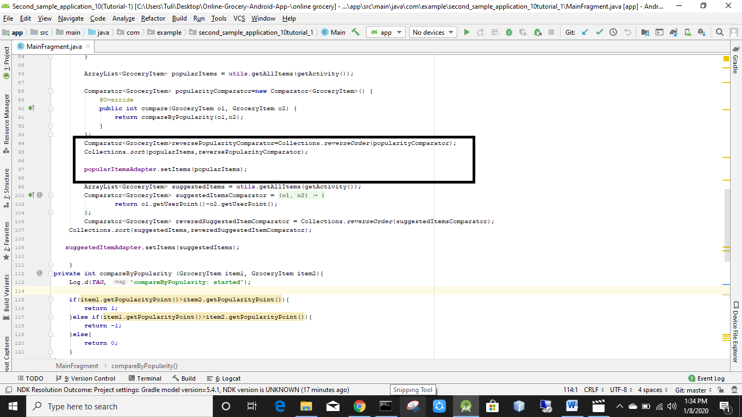

Popularitems er jaigai allitems hobe

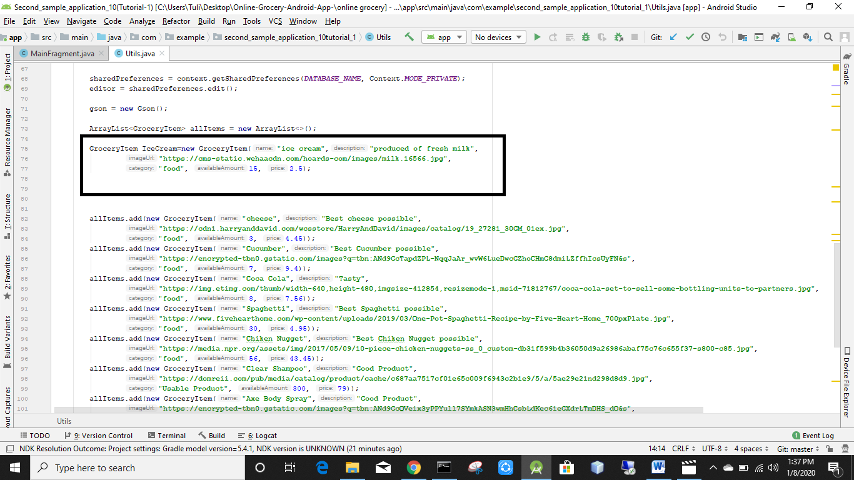

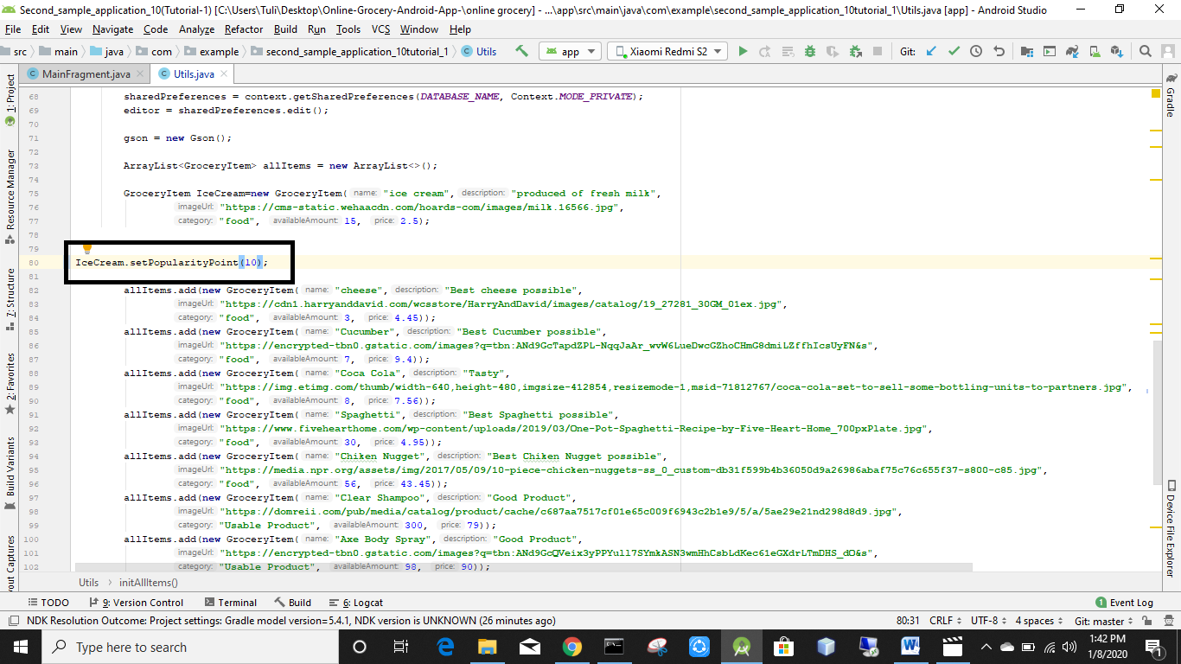

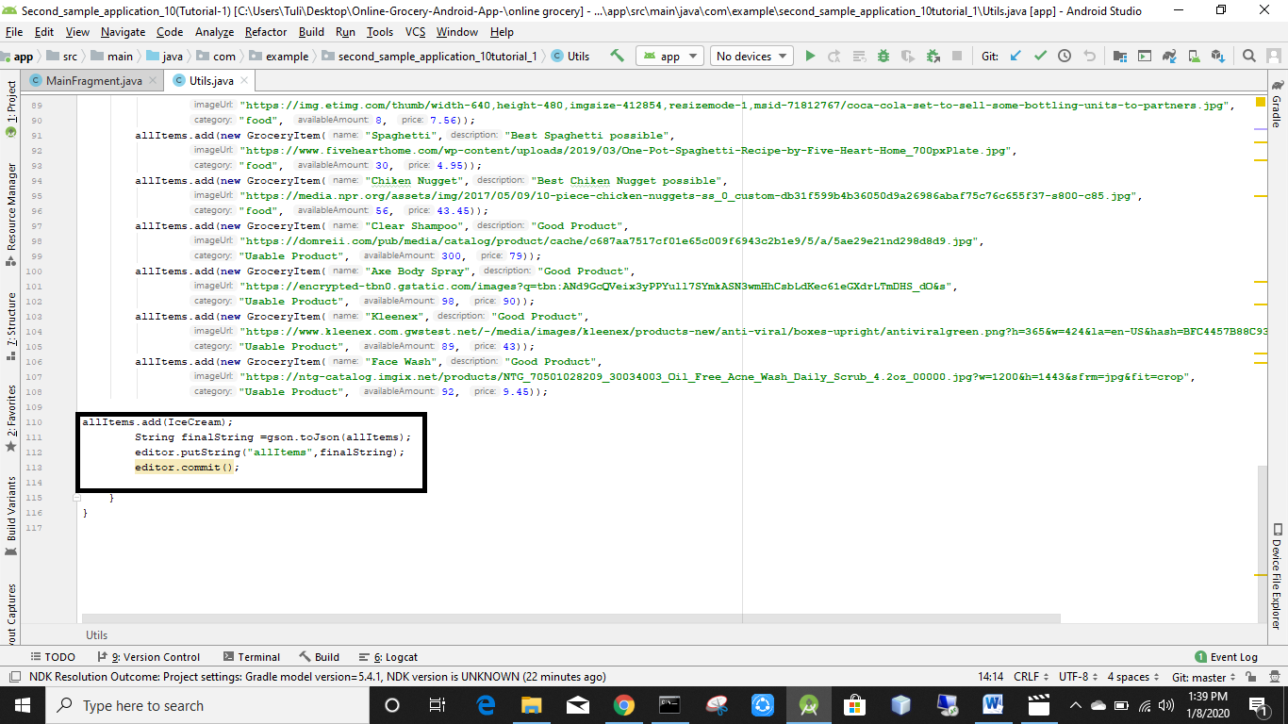

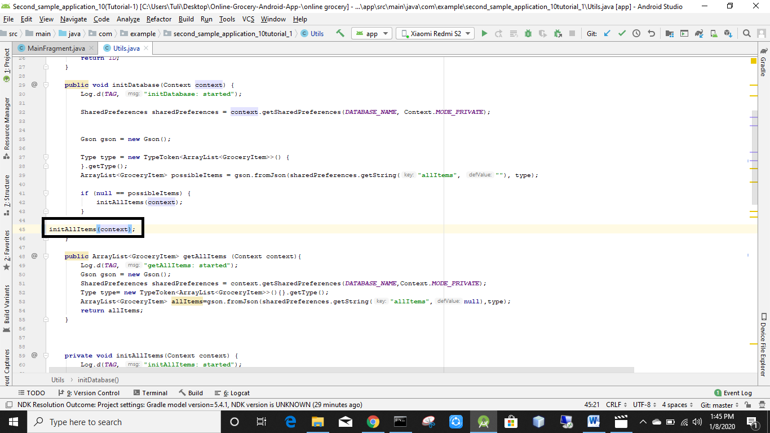

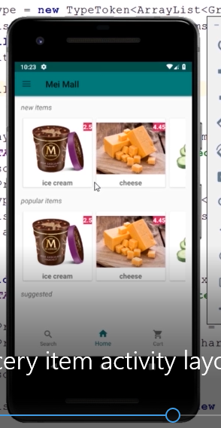

Popular items eo ekta recycler view dekhacche

done

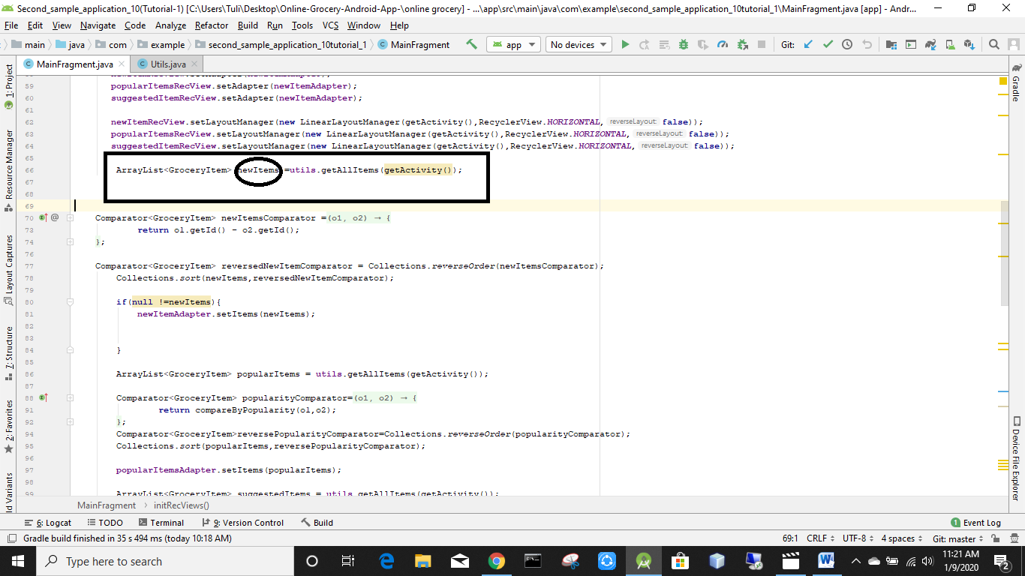

New items er jaigai aage all items chilo  
allitems ta k refactor kore rename korechi new items  
onnano all items er jaiga gulo o auto new item hoye geche

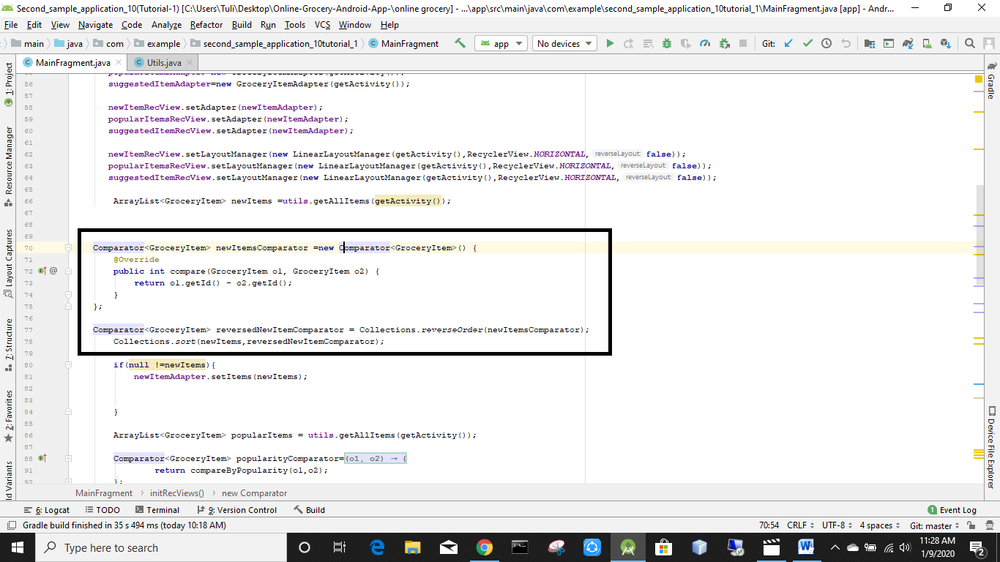

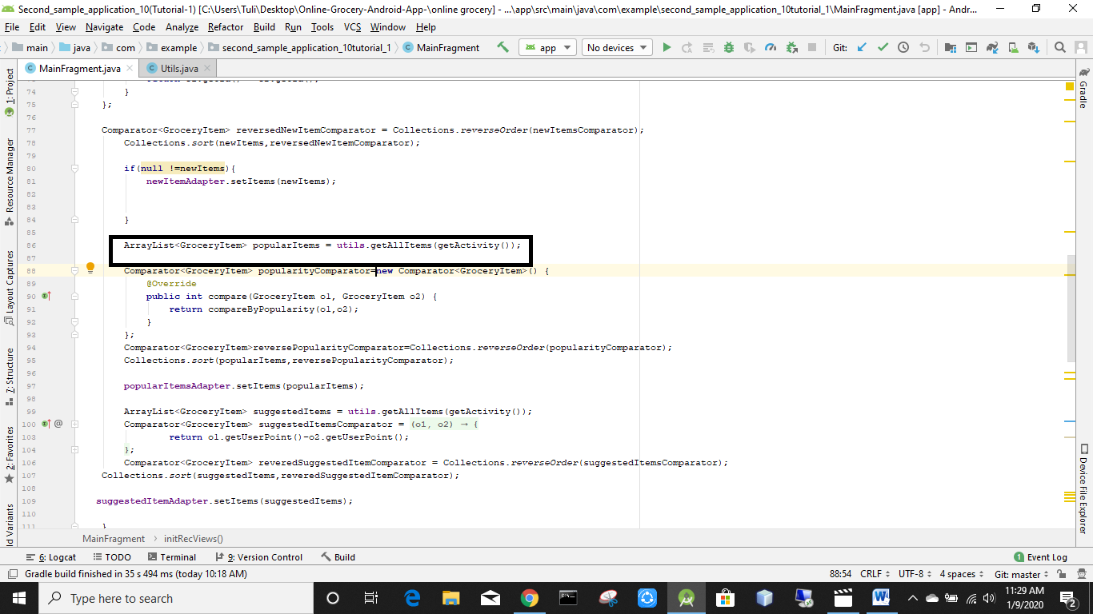

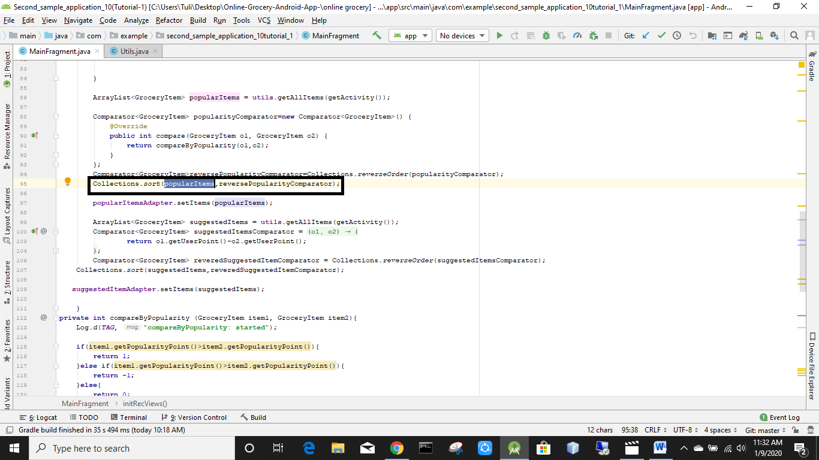

New items k change kore popular items likhbo

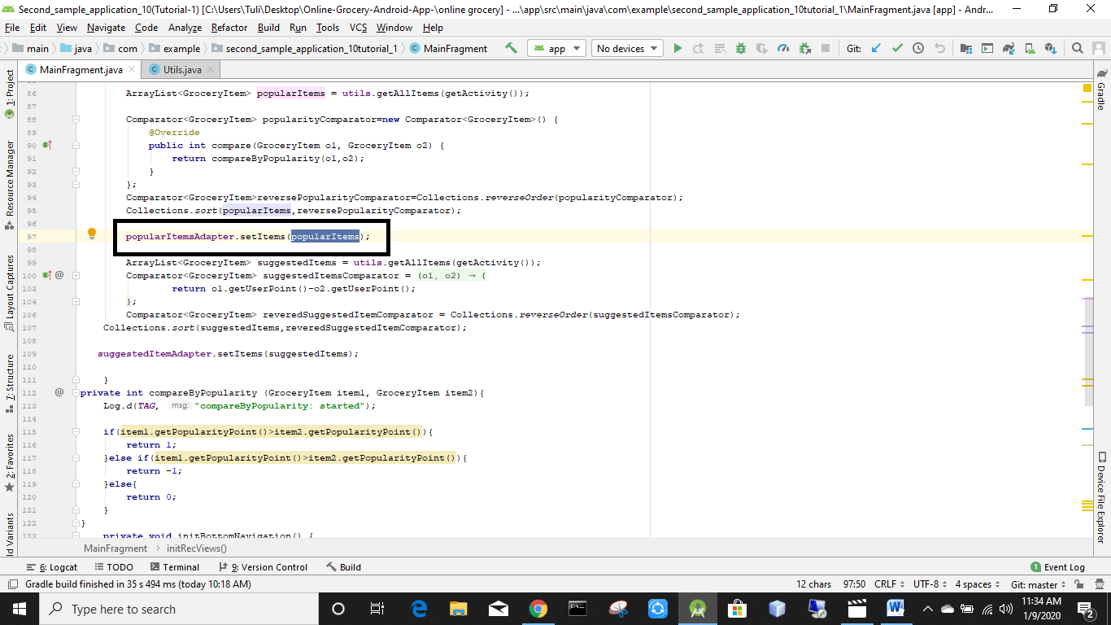

New items k kete popular items likhbo

Run the app

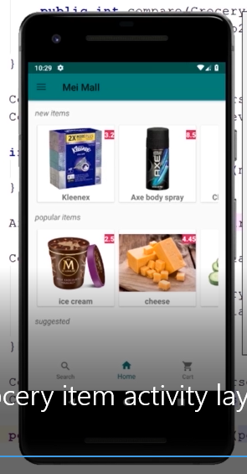

New item r popular item different

done

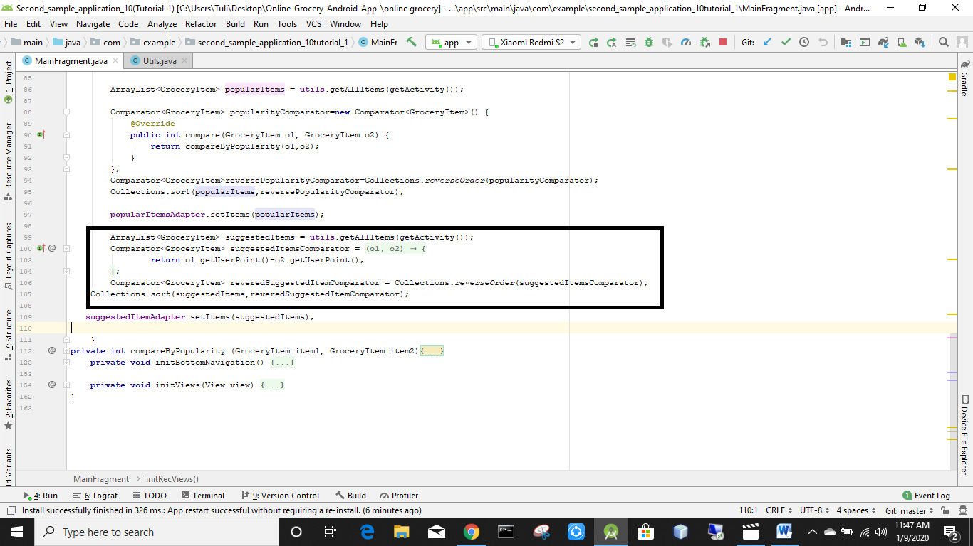

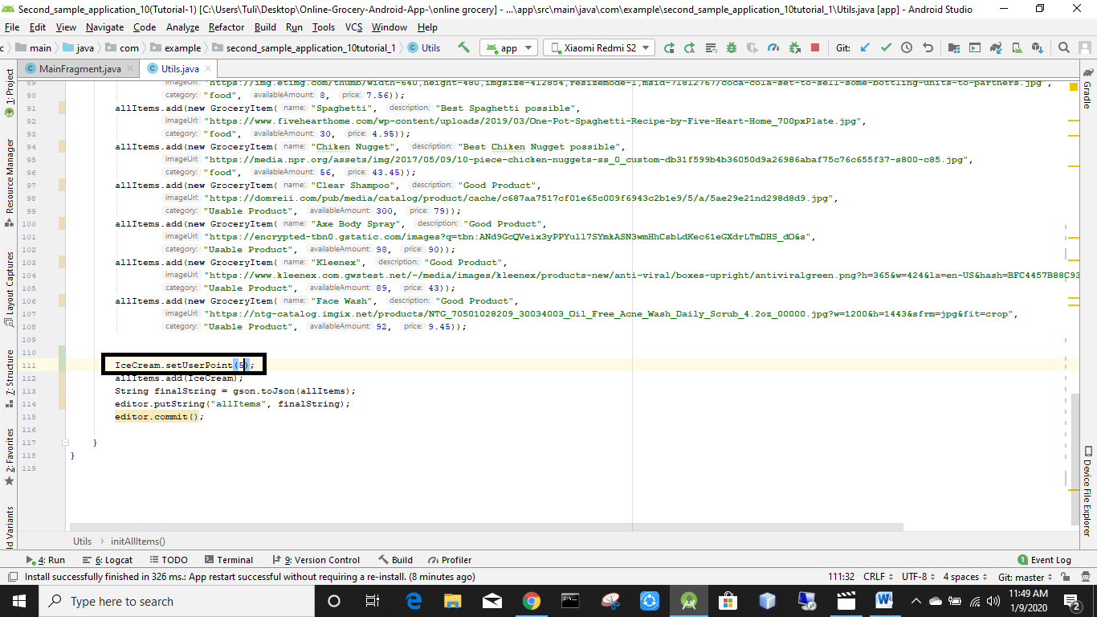

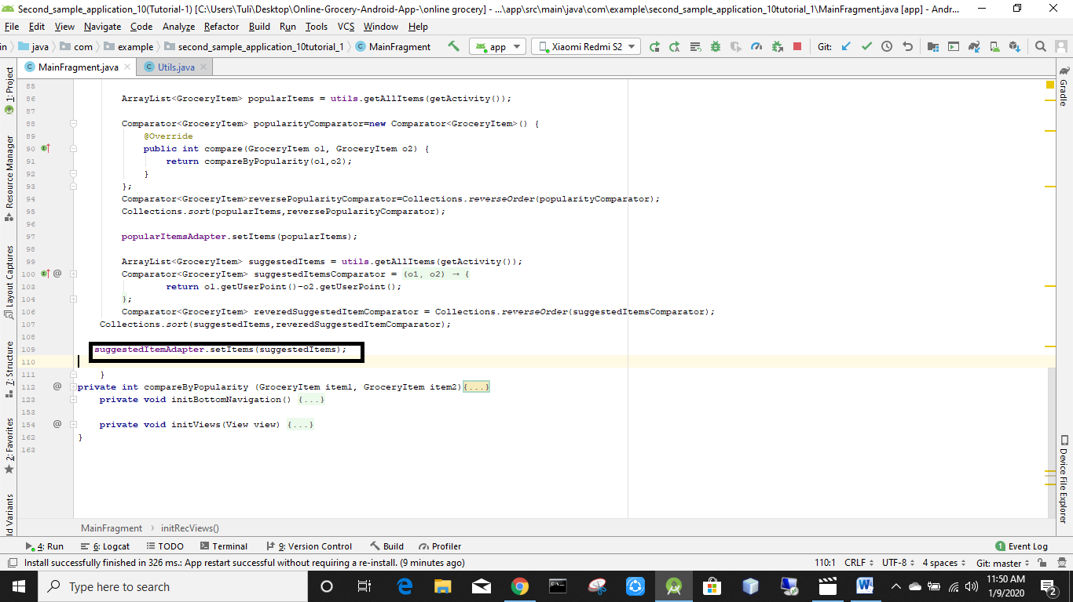

Run the app

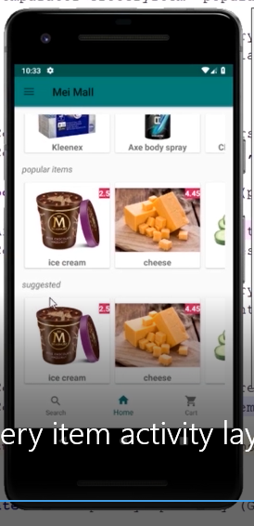

New items ,popular items, suggested item sob show korche

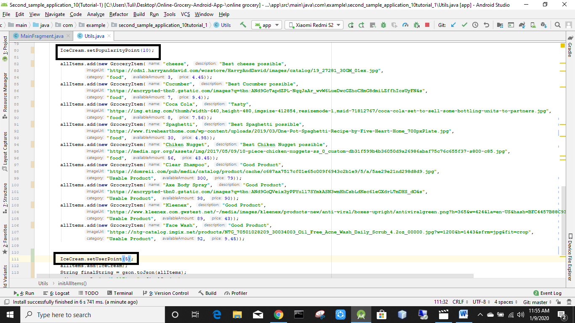

Cut those line

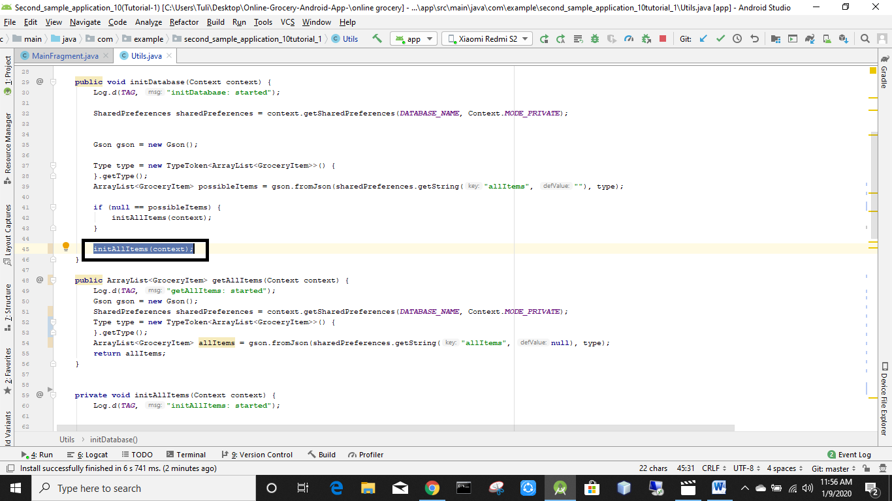

Cut these line

Notun ekta empty activity khulbo  
nam dibo GroceryItemActivity

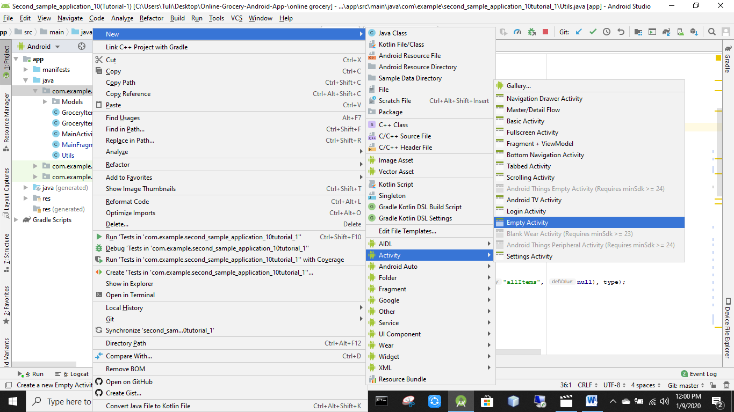

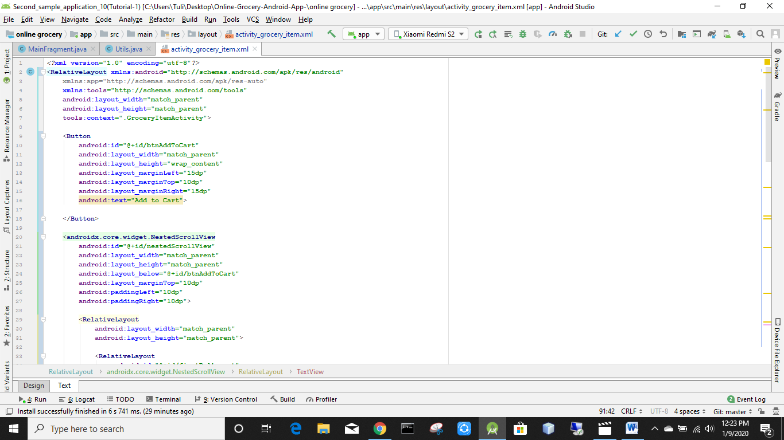

*<?***xml version="1.0" encoding="utf-8"***?>*<**RelativeLayout xmlns:android="http://schemas.android.com/apk/res/android"  
 xmlns:app="http://schemas.android.com/apk/res-auto"  
 xmlns:tools="http://schemas.android.com/tools"  
 android:layout_width="match_parent"  
 android:layout_height="match_parent"  
 tools:context=".GroceryItemActivity"**>  
  
 <**Button  
 android:id="@+id/btnAddToCart"  
 android:layout_width="match_parent"  
 android:layout_height="wrap_content"  
 android:layout_marginLeft="15dp"  
 android:layout_marginTop="10dp"  
 android:layout_marginRight="15dp"  
 android:text="Add to Cart"**>  
  
 </**Button**>  
  
 <**androidx.core.widget.NestedScrollView  
 android:id="@+id/nestedScrollView"  
 android:layout_width="match_parent"  
 android:layout_height="match_parent"  
 android:layout_below="@+id/btnAddToCart"  
 android:layout_marginTop="10dp"  
 android:paddingLeft="10dp"  
 android:paddingRight="10dp"**>  
  
 <**RelativeLayout  
 android:layout_width="match_parent"  
 android:layout_height="match_parent"**>  
  
 <**RelativeLayout  
 android:id="@+id/firstRelLayout"  
 android:layout_width="match_parent"  
 android:layout_height="wrap_content"**>  
  
  
 <**TextView  
 android:id="@+id/txtName"  
 android:layout_width="wrap_content"  
 android:layout_height="wrap_content"  
 android:text="name"  
 android:textSize="18sp"  
 android:textStyle="bold"**>  
  
  
 </**TextView**>  
  
 <**TextView  
 android:layout_width="wrap_content"  
 android:layout_height="wrap_content"  
 android:layout_alignParentRight="true"  
 android:text="price"  
 android:textColor="@color/colorAccent"  
 android:textSize="16sp"  
 android:textStyle="bold"**>  
  
 </**TextView**>  
  
  
 </**RelativeLayout**>  
  
 <**ImageView  
 android:id="@+id/itemImage"  
 android:layout_width="250dp"  
 android:layout_height="250dp"  
 android:layout_below="@+id/firstRelLayout"  
 android:layout_centerHorizontal="true"  
 android:layout_marginTop="10dp"**>  
  
 </**ImageView**>  
  
 <**TextView  
 android:id="@+id/txtAvailability"  
 android:layout_width="wrap_content"  
 android:layout_height="wrap_content"  
 android:layout_below="@+id/itemImage"  
 android:layout_marginTop="10dp"  
 android:text="no item available"**>  
  
 </**TextView**>  
  
 <**TextView  
 android:id="@+id/txtDesc"  
 android:layout_width="wrap_content"  
 android:layout_height="wrap_content"  
 android:layout_below="@+id/txtAvailability"  
 android:layout_marginTop="10dp"  
 android:text="description in here"  
 android:textStyle="italic"**>  
  
 </**TextView**>  
  
 </**RelativeLayout**>  
  
 </**androidx.core.widget.NestedScrollView**>  
  
</**RelativeLayout**>

Drawable e gye image asset er maddhome emplty star, add & filled star er picture nibo

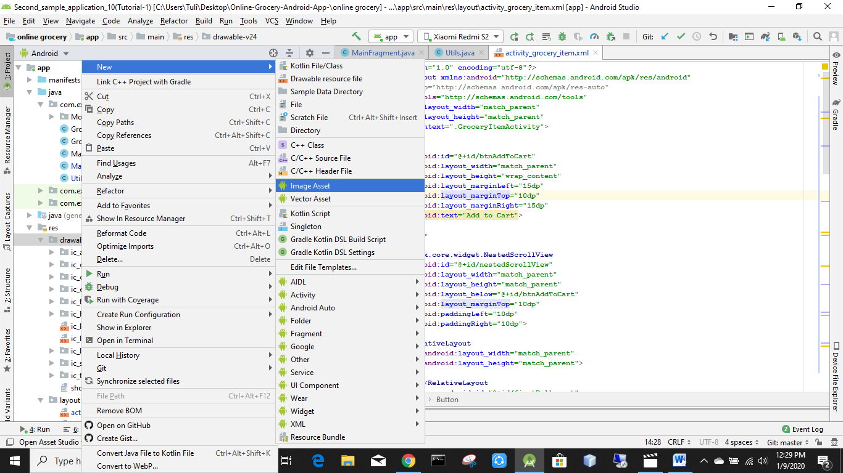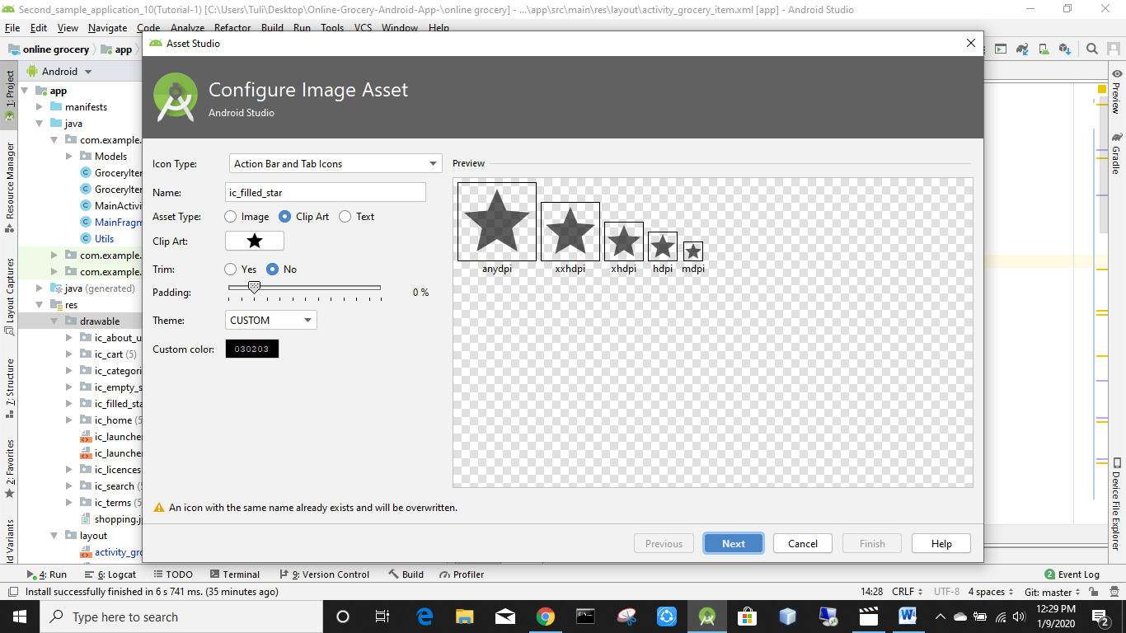

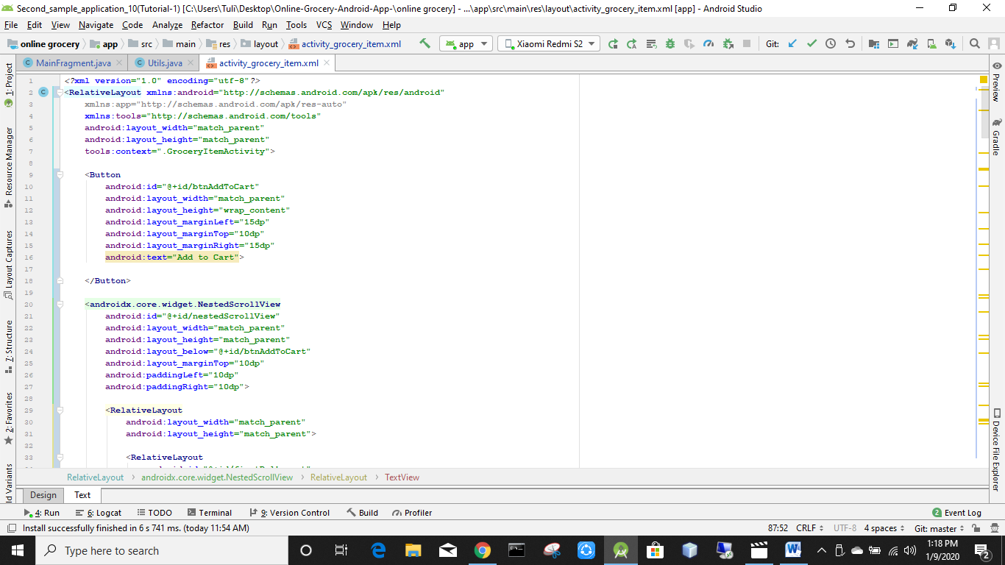

*<?***xml version="1.0" encoding="utf-8"***?>*<**RelativeLayout xmlns:android="http://schemas.android.com/apk/res/android"  
 xmlns:app="http://schemas.android.com/apk/res-auto"  
 xmlns:tools="http://schemas.android.com/tools"  
 android:layout_width="match_parent"  
 android:layout_height="match_parent"  
 tools:context=".GroceryItemActivity"**>  
  
 <**Button  
 android:id="@+id/btnAddToCart"  
 android:layout_width="match_parent"  
 android:layout_height="wrap_content"  
 android:layout_marginLeft="15dp"  
 android:layout_marginTop="10dp"  
 android:layout_marginRight="15dp"  
 android:text="Add to Cart"**>  
  
 </**Button**>  
  
 <**androidx.core.widget.NestedScrollView  
 android:id="@+id/nestedScrollView"  
 android:layout_width="match_parent"  
 android:layout_height="match_parent"  
 android:layout_below="@+id/btnAddToCart"  
 android:layout_marginTop="10dp"  
 android:paddingLeft="10dp"  
 android:paddingRight="10dp"**>  
  
 <**RelativeLayout  
 android:layout_width="match_parent"  
 android:layout_height="match_parent"**>  
  
 <**RelativeLayout  
 android:id="@+id/firstRelLayout"  
 android:layout_width="match_parent"  
 android:layout_height="wrap_content"**>  
  
  
 <**TextView  
 android:id="@+id/txtName"  
 android:layout_width="wrap_content"  
 android:layout_height="wrap_content"  
 android:text="name"  
 android:textSize="18sp"  
 android:textStyle="bold"**>  
  
  
 </**TextView**>  
  
 <**TextView  
 android:layout_width="wrap_content"  
 android:layout_height="wrap_content"  
 android:layout_alignParentRight="true"  
 android:text="price"  
 android:textColor="@color/colorAccent"  
 android:textSize="16sp"  
 android:textStyle="bold"**>  
  
 </**TextView**>  
  
  
 </**RelativeLayout**>  
  
 <**ImageView  
 android:src="@mipmap/ic_launcher"  
 android:id="@+id/itemImage"  
 android:layout_width="250dp"  
 android:layout_height="250dp"  
 android:layout_below="@+id/firstRelLayout"  
 android:layout_centerHorizontal="true"  
 android:layout_marginTop="10dp"**>  
  
 </**ImageView**>  
  
 <**TextView  
 android:id="@+id/txtAvailability"  
 android:layout_width="wrap_content"  
 android:layout_height="wrap_content"  
 android:layout_below="@+id/itemImage"  
 android:layout_marginTop="10dp"  
 android:text="no item available"**>  
  
 </**TextView**>  
  
 <**TextView  
 android:id="@+id/txtDesc"  
 android:layout_width="wrap_content"  
 android:layout_height="wrap_content"  
 android:layout_below="@+id/txtAvailability"  
 android:layout_marginTop="10dp"  
 android:text="description in here"  
 android:textStyle="italic"**>  
  
 </**TextView**>  
  
 <**RelativeLayout  
 android:id="@+id/starsRelLayout"  
 android:layout_width="wrap_content"  
 android:layout_height="wrap_content"  
 android:layout_below="@id/txtAvailability"  
 android:layout_alignParentRight="true"**>  
  
 <**RelativeLayout  
 android:id="@+id/firstStartRelLayout"  
 android:layout_width="wrap_content"  
 android:layout_height="wrap_content"**>  
  
 <**ImageView  
 android:id="@+id/firstEmptyStar"  
 android:layout_width="wrap_content"  
 android:layout_height="wrap_content"  
 android:src="@drawable/ic_empty_star"**>  
  
  
 </**ImageView**>  
  
 <**ImageView  
 android:id="@+id/firstFilledStar"  
 android:layout_width="wrap_content"  
 android:layout_height="wrap_content"  
 android:src="@drawable/ic_filled_star"  
 android:visibility="gone"**>  
  
  
 </**ImageView**>  
 </**RelativeLayout**>  
  
  
 <**RelativeLayout  
 android:id="@+id/secondStartRelLayout"  
 android:layout_width="wrap_content"  
 android:layout_height="wrap_content"  
 android:layout_toRightOf="@+id/firstStartRelLayout"**>  
  
 <**ImageView  
 android:id="@+id/secondEmptyStar"  
 android:layout_width="wrap_content"  
 android:layout_height="wrap_content"  
 android:src="@drawable/ic_empty_star"**>  
  
  
 </**ImageView**>  
  
 <**ImageView  
 android:id="@+id/secondFilledStar"  
 android:layout_width="wrap_content"  
 android:layout_height="wrap_content"  
 android:src="@drawable/ic_filled_star"  
 android:visibility="gone"**>  
  
  
 </**ImageView**>  
 </**RelativeLayout**>  
  
 <**RelativeLayout  
 android:id="@+id/thirdStartRelLayout"  
 android:layout_width="wrap_content"  
 android:layout_height="wrap_content"  
 android:layout_toRightOf="@+id/secondStartRelLayout"**>  
  
 <**ImageView  
 android:id="@+id/thirdEmptyStar"  
 android:layout_width="wrap_content"  
 android:layout_height="wrap_content"  
 android:src="@drawable/ic_empty_star"**>  
  
  
 </**ImageView**>  
  
 <**ImageView  
 android:id="@+id/thirdFilledStar"  
 android:layout_width="wrap_content"  
 android:layout_height="wrap_content"  
 android:src="@drawable/ic_filled_star"  
 android:visibility="gone"**>  
  
  
 </**ImageView**>  
 </**RelativeLayout**>  
  
  
 </**RelativeLayout**>  
  
 <**TextView  
 android:id="@+id/reviewExplained"  
 android:layout_width="wrap_content"  
 android:layout_height="wrap_content"  
 android:layout_below="@+id/txtDesc"  
 android:layout_marginLeft="10dp"  
 android:layout_marginTop="25dp"  
 android:text="Reviews: "  
 android:textStyle="bold|italic"**>  
  
 </**TextView**>  
  
 <**RelativeLayout  
 android:layout_marginTop="5dp"  
 android:layout_below="@+id/reviewExplained"  
 android:id="@+id/addReviewRelLayout"  
 android:layout_width="wrap_content"  
 android:layout_height="wrap_content"**>  
  
 <**ImageView  
 android:id="@+id/addImage"  
 android:src="@drawable/ic_add"  
 android:layout_width="wrap_content"  
 android:layout_height="wrap_content"**>  
  
 </**ImageView**>  
  
 <**TextView  
 android:layout_marginLeft="10dp"  
 android:layout_toRightOf="@+id/addImage"  
 android:textColor="@color/colorAccent"  
 android:text="(Add a review)"  
 android:layout_width="wrap_content"  
 android:layout_height="wrap_content"**>  
  
 </**TextView**>  
  
 </**RelativeLayout**>  
  
 <**androidx.recyclerview.widget.RecyclerView  
 android:layout_marginTop="10dp"  
 android:layout_below="@+id/addReviewRelLayout"  
 android:id="@+id/reviewsRecView"  
 android:layout_width="match_parent"  
 android:layout_height="wrap_content"**>  
  
 </**androidx.recyclerview.widget.RecyclerView**>  
  
 </**RelativeLayout**>  
  
  
 </**androidx.core.widget.NestedScrollView**>  
  
</**RelativeLayout**>

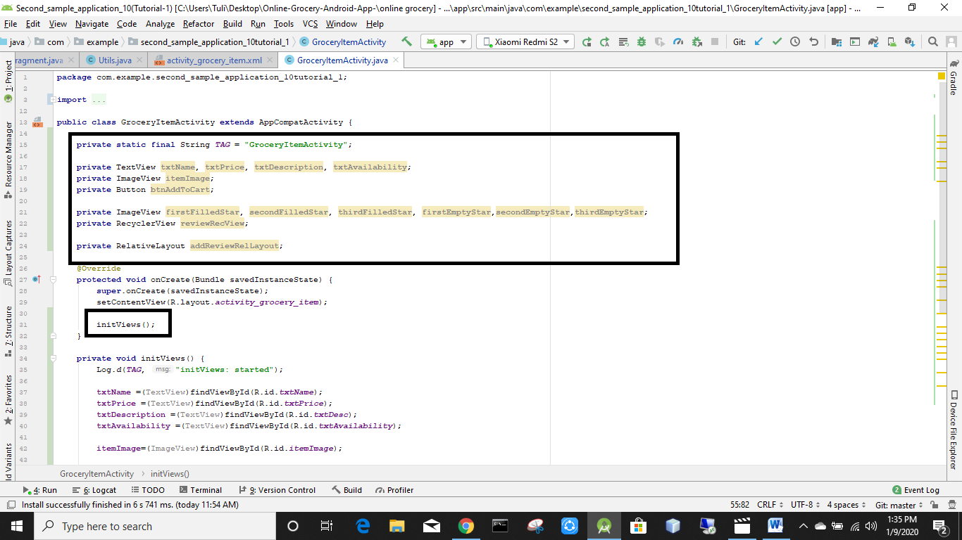

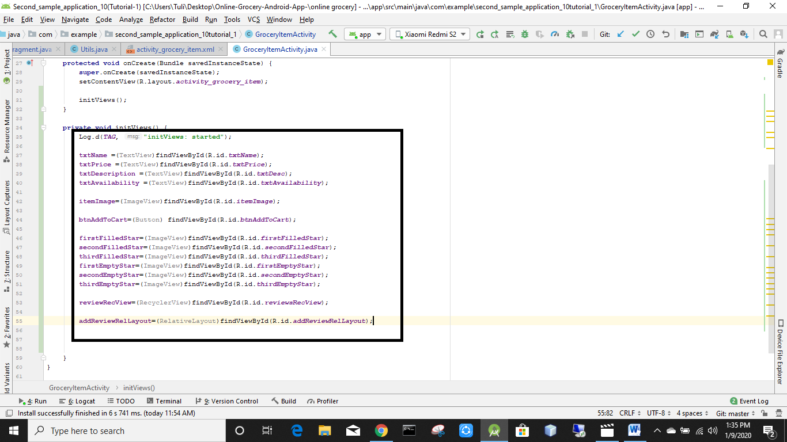

Tutorial 1  
10. Second Sample Application - Create an online grocery  
5. Show items in grocery item activity - add review

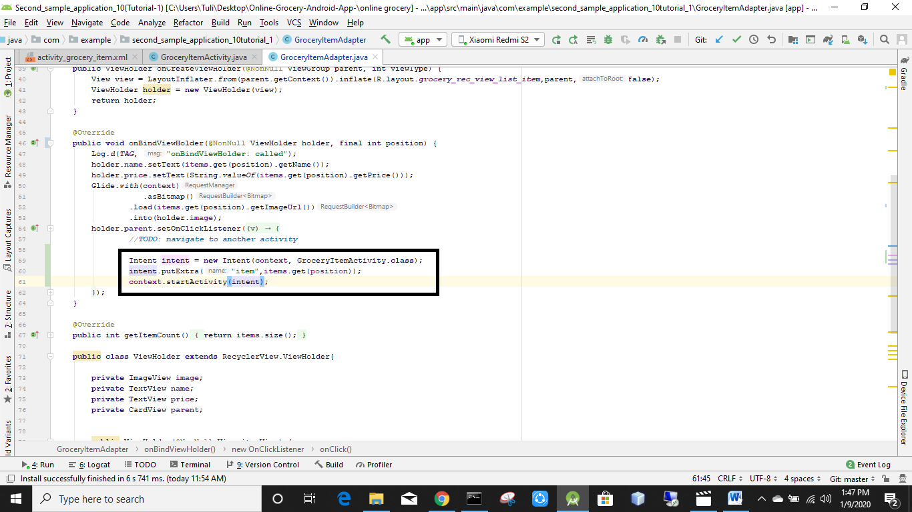

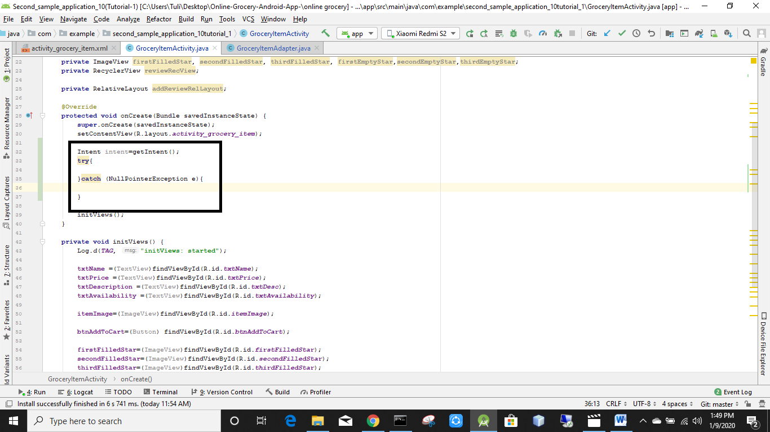

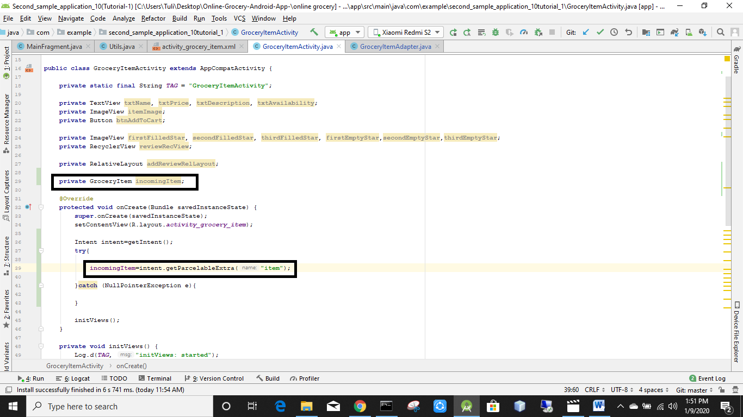

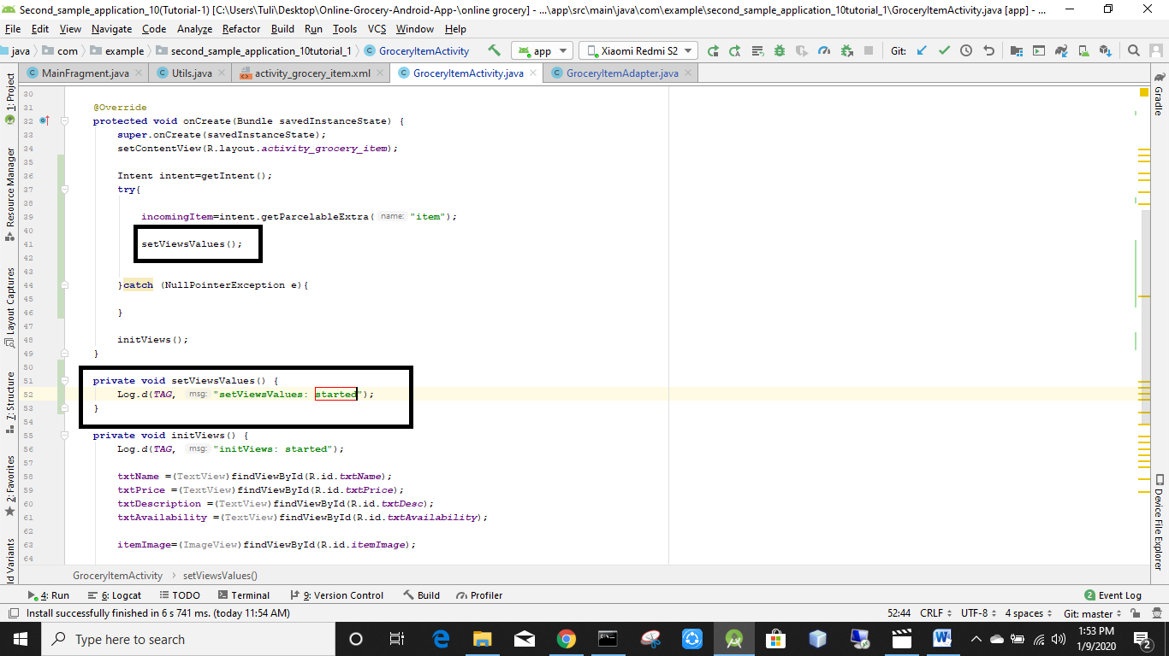

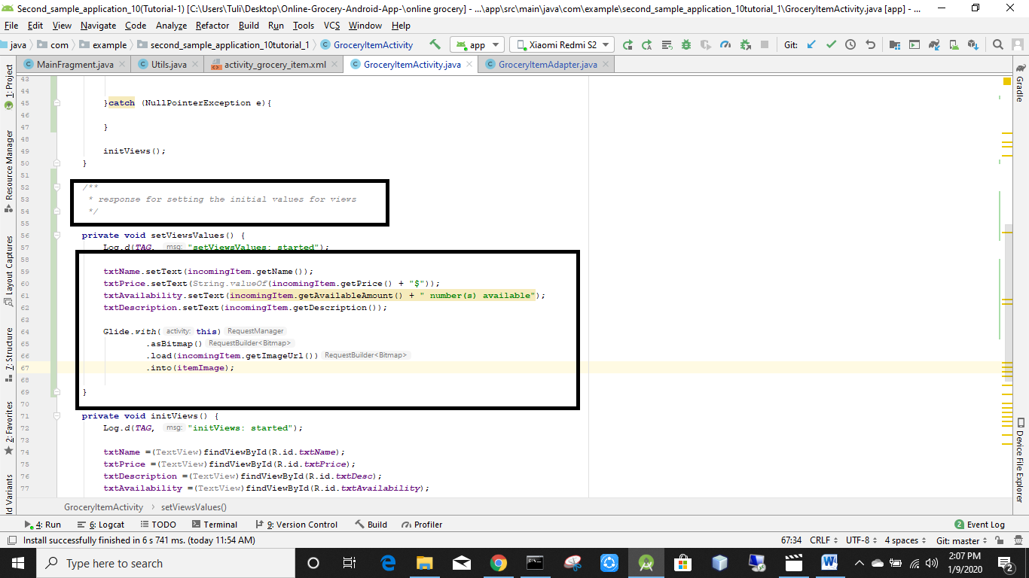

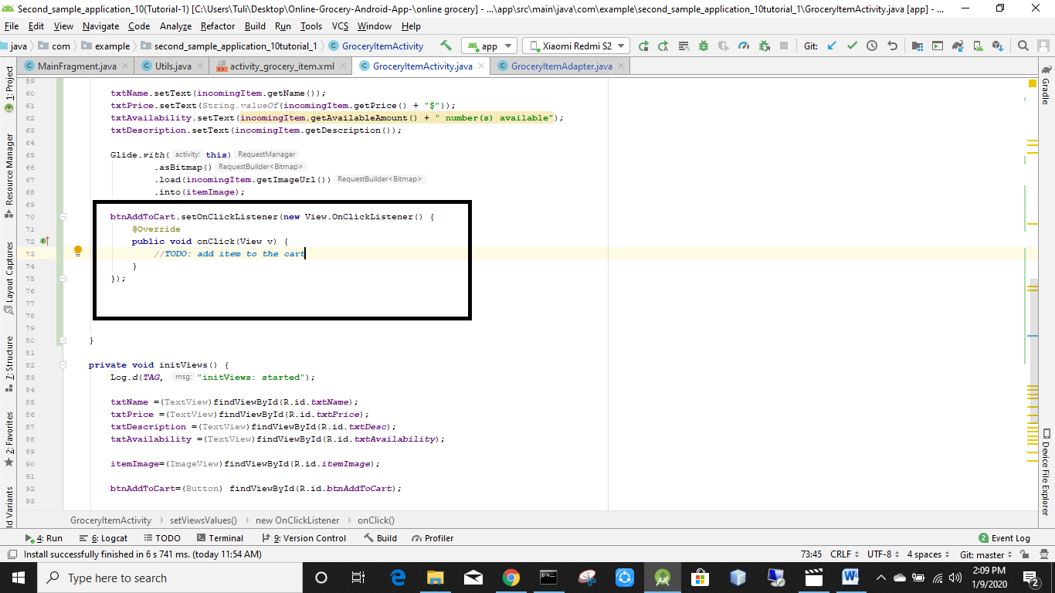

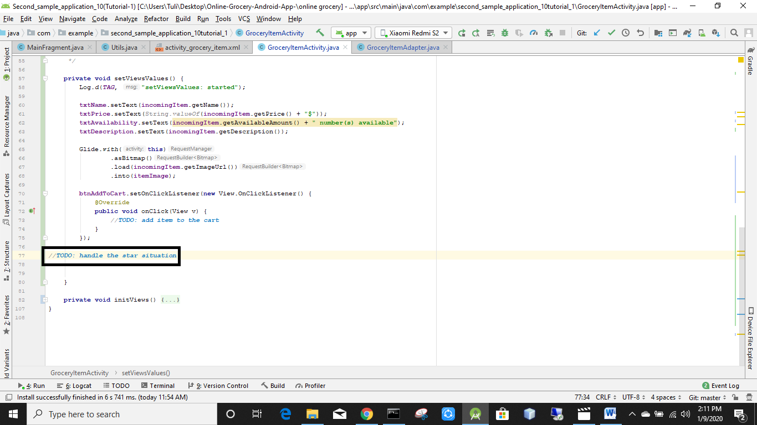

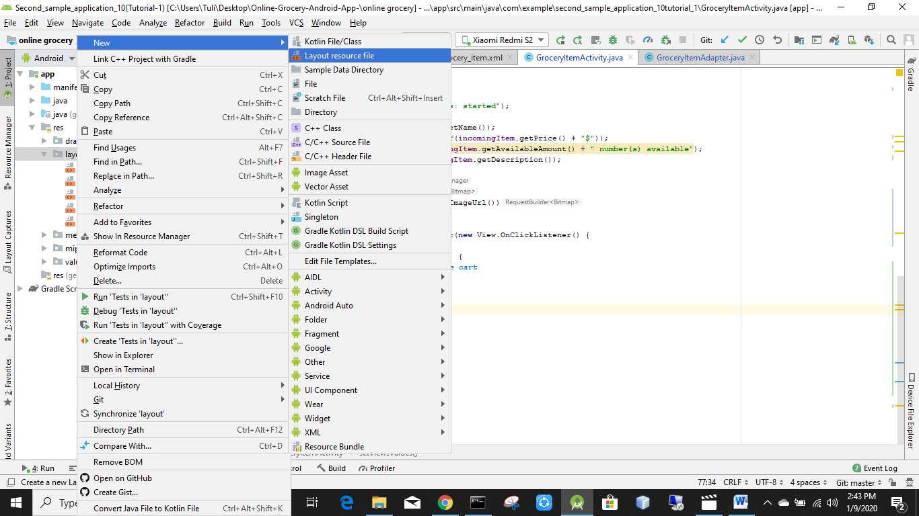

Named it review_adapter_list_item

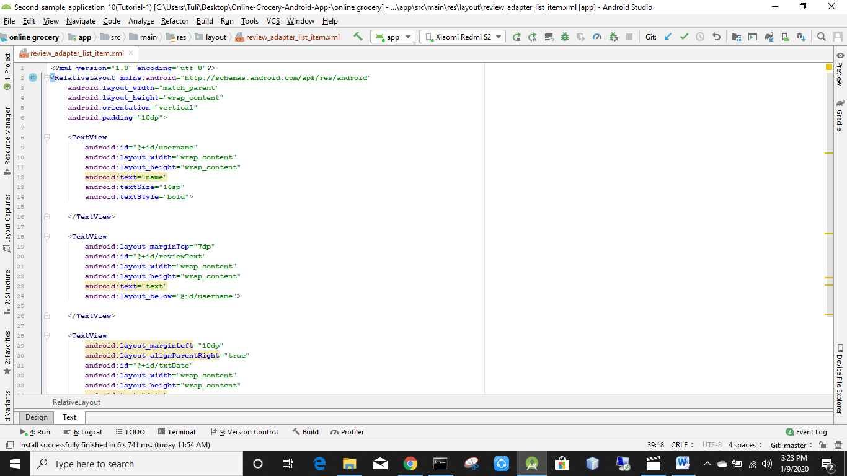

*<?***xml version="1.0" encoding="utf-8"***?>*<**RelativeLayout xmlns:android="http://schemas.android.com/apk/res/android"  
 android:layout_width="match_parent"  
 android:layout_height="wrap_content"  
 android:orientation="vertical"  
 android:padding="10dp"**>  
  
 <**TextView  
 android:id="@+id/username"  
 android:layout_width="wrap_content"  
 android:layout_height="wrap_content"  
 android:text="name"  
 android:textSize="16sp"  
 android:textStyle="bold"**>  
  
 </**TextView**>  
  
 <**TextView  
 android:layout_marginTop="7dp"  
 android:id="@+id/reviewText"  
 android:layout_width="wrap_content"  
 android:layout_height="wrap_content"  
 android:text="text"  
 android:layout_below="@id/username"**>  
  
 </**TextView**>  
  
 <**TextView  
 android:layout_marginLeft="10dp"  
 android:layout_alignParentRight="true"  
 android:id="@+id/txtDate"  
 android:layout_width="wrap_content"  
 android:layout_height="wrap_content"  
 android:text="date"  
 android:layout_below="@id/reviewText"**>  
  
 </**TextView**>  
  
</**RelativeLayout**>

Java class create korbo Reviews adapter nam e

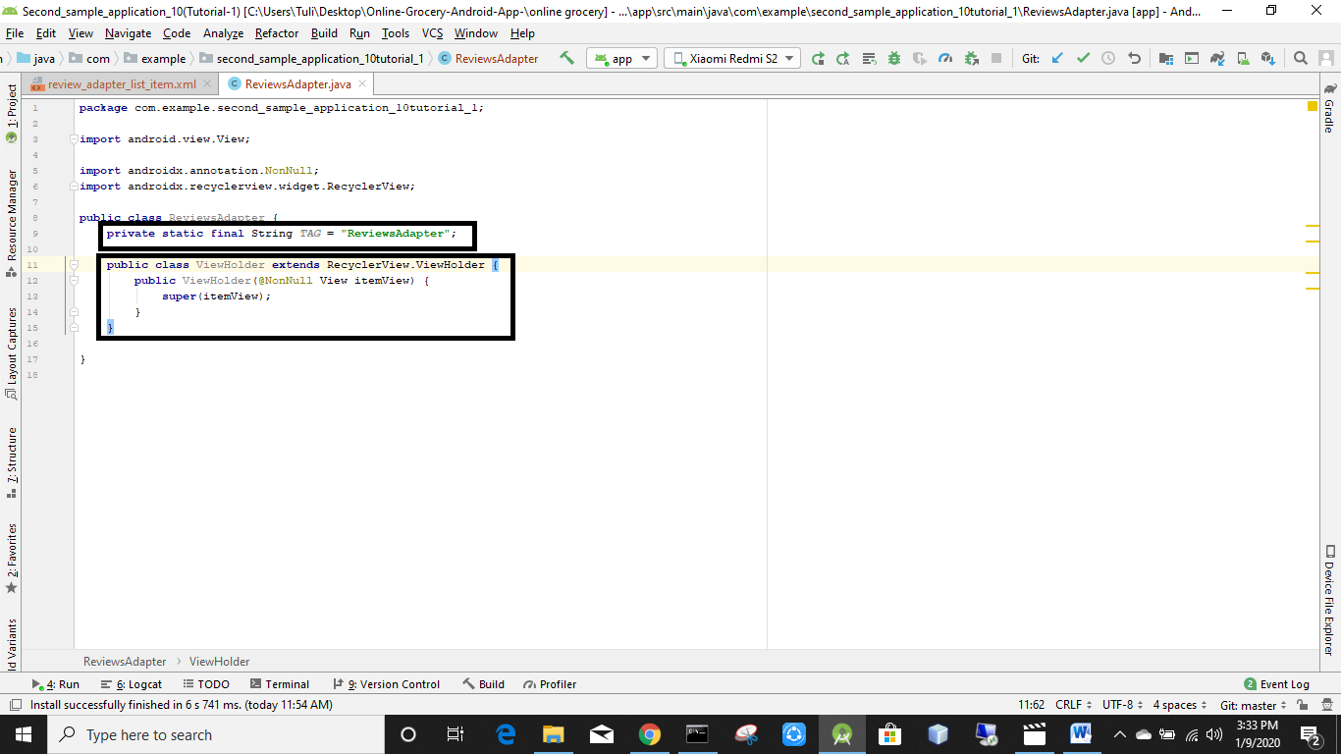

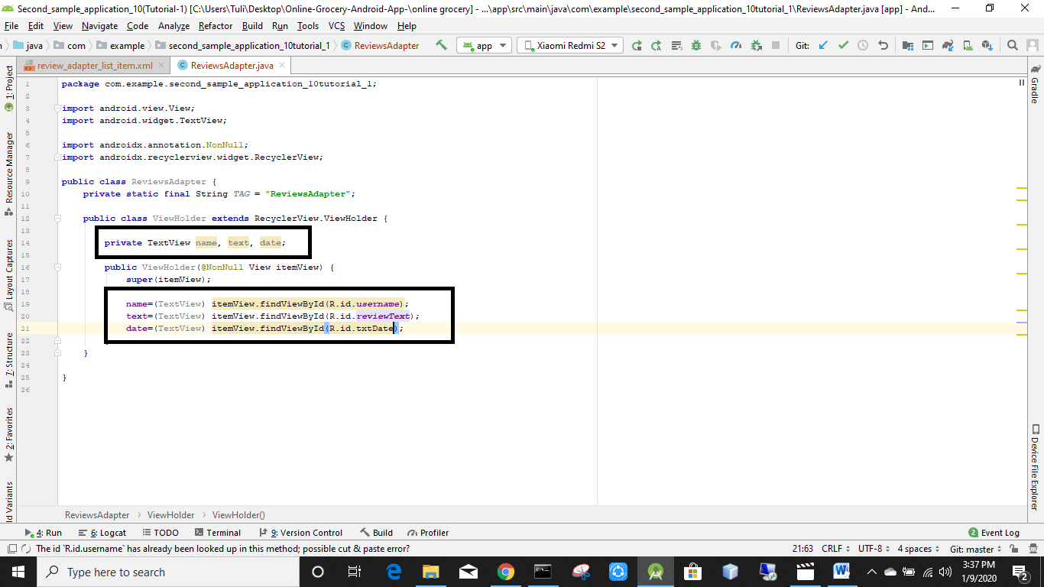

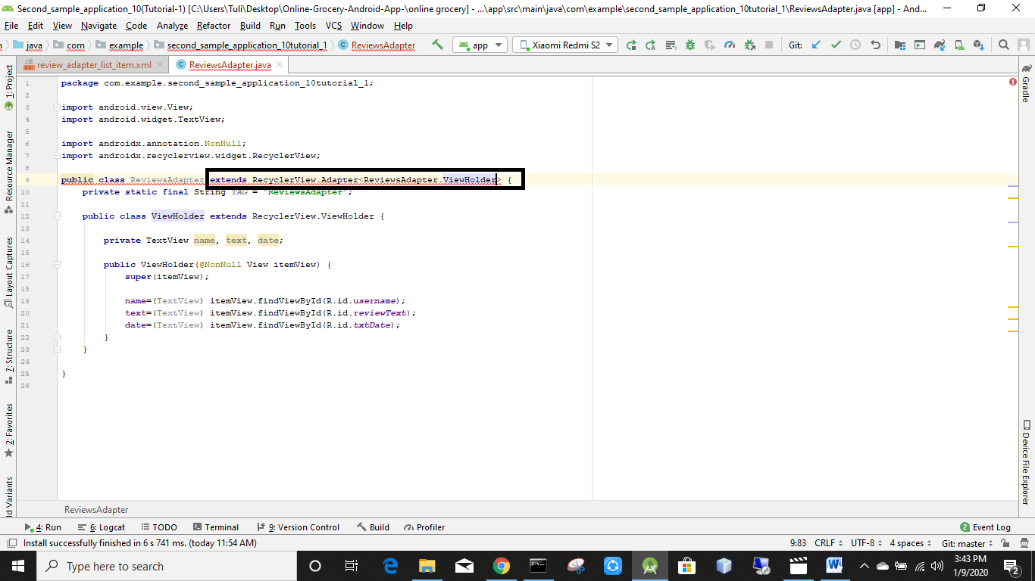

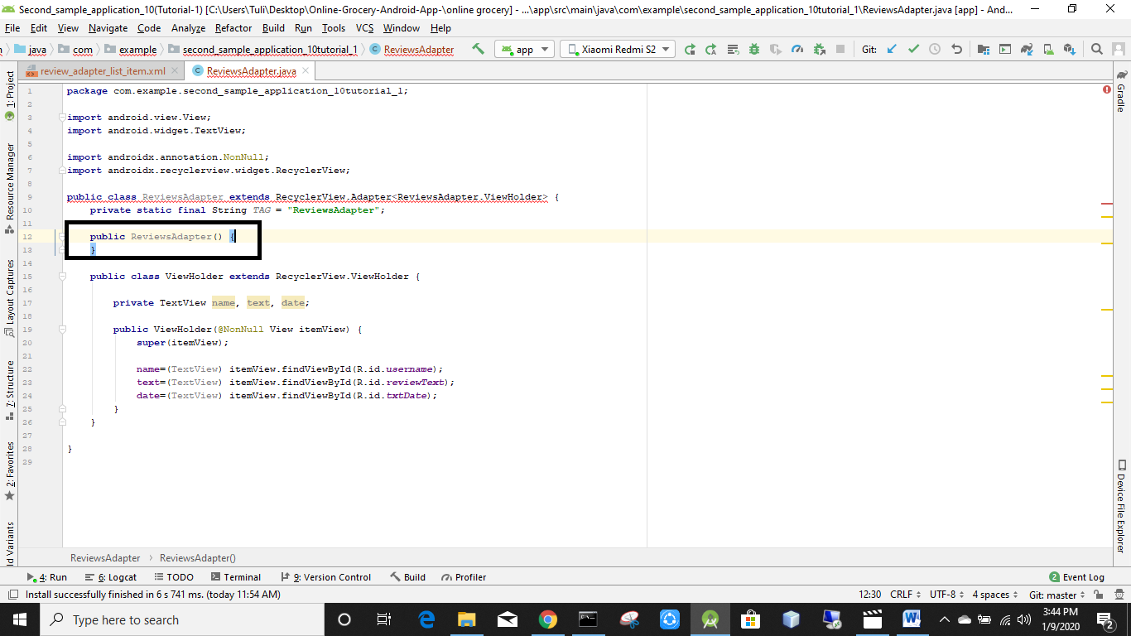

Rightclick🡪generate🡪constructor

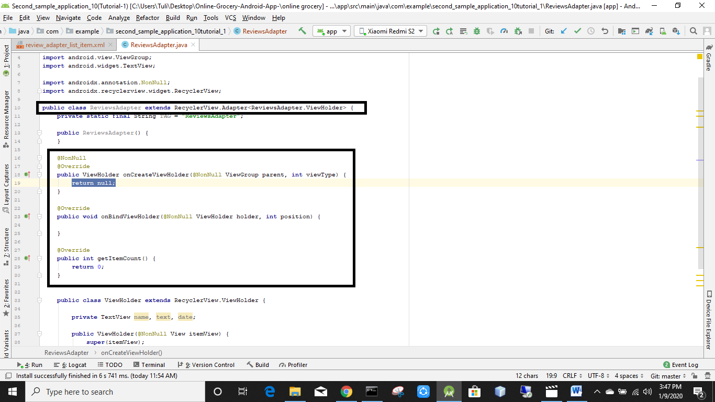

Recyclerview.adapter<ReviewAdapter.ViewHolder er upor alt+ent chapbo

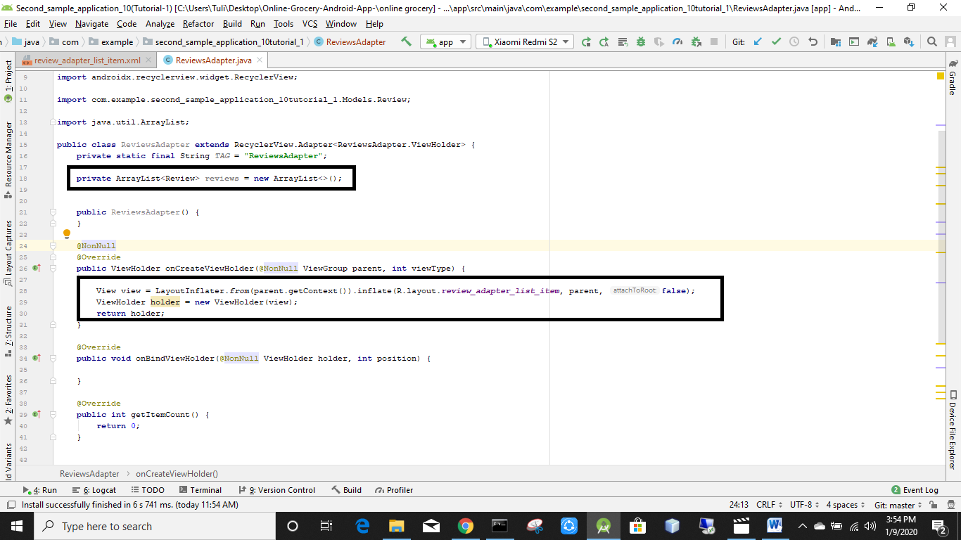

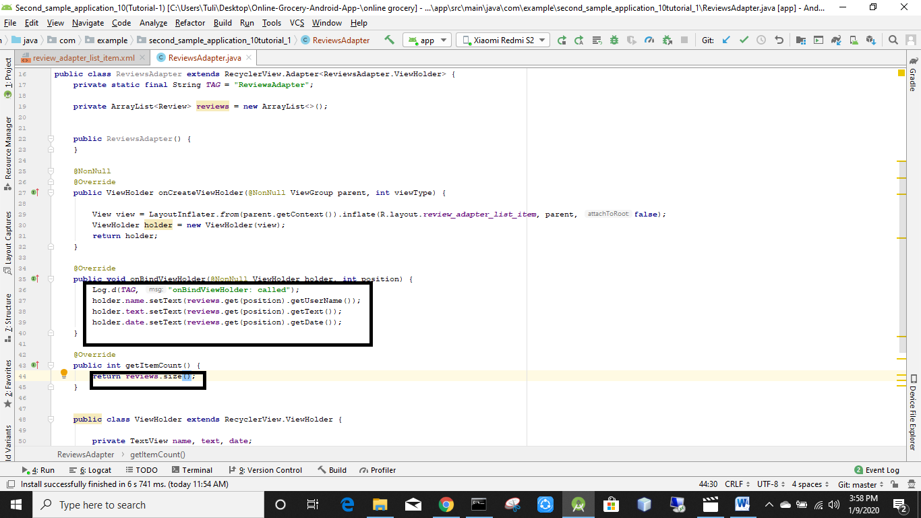

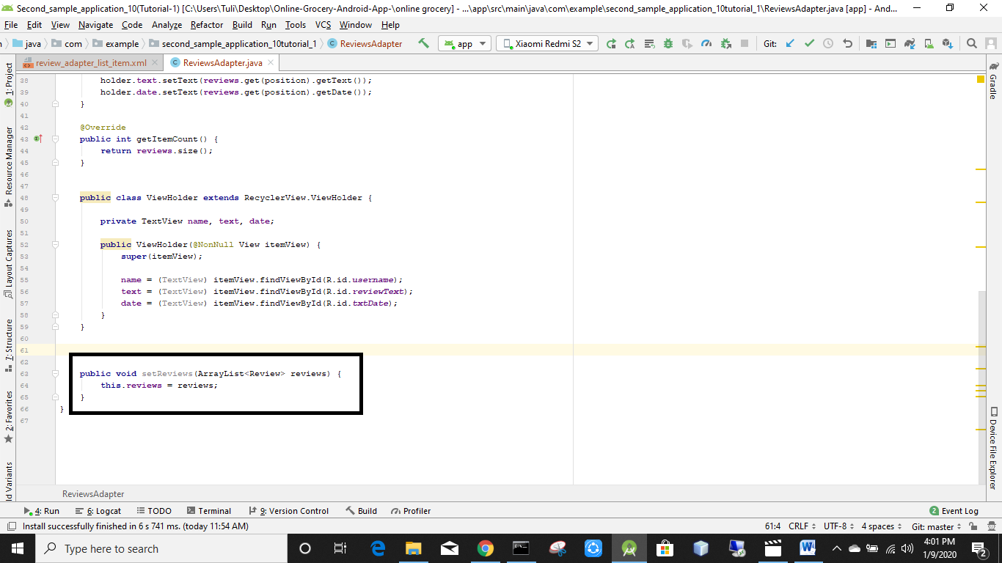

Generate🡪getter setter korsi

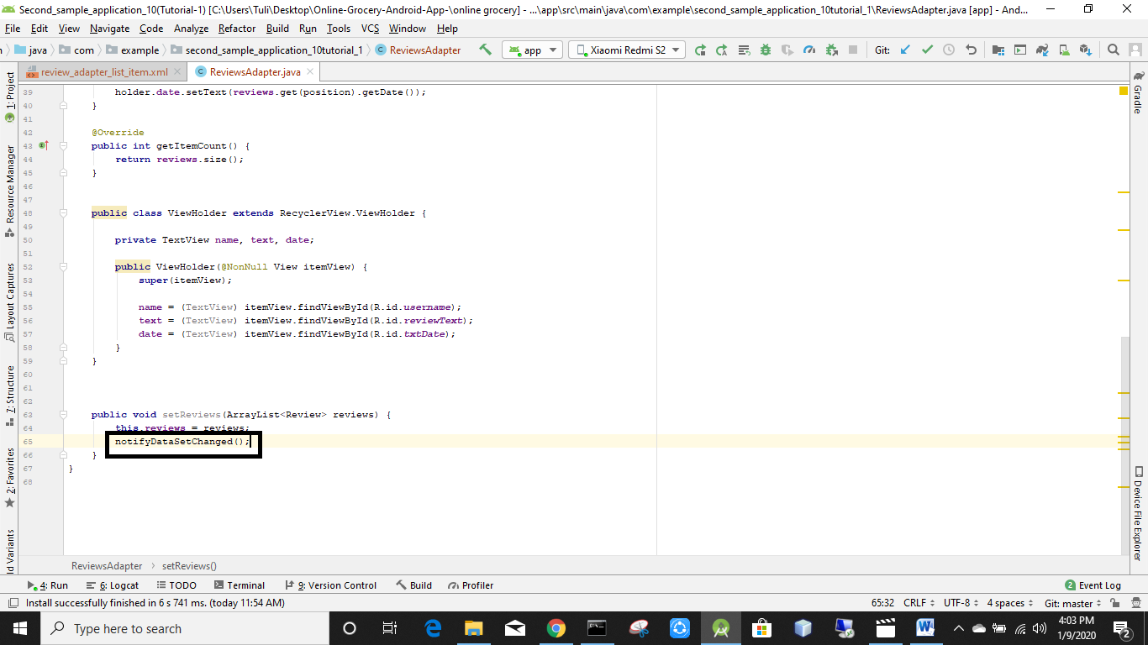

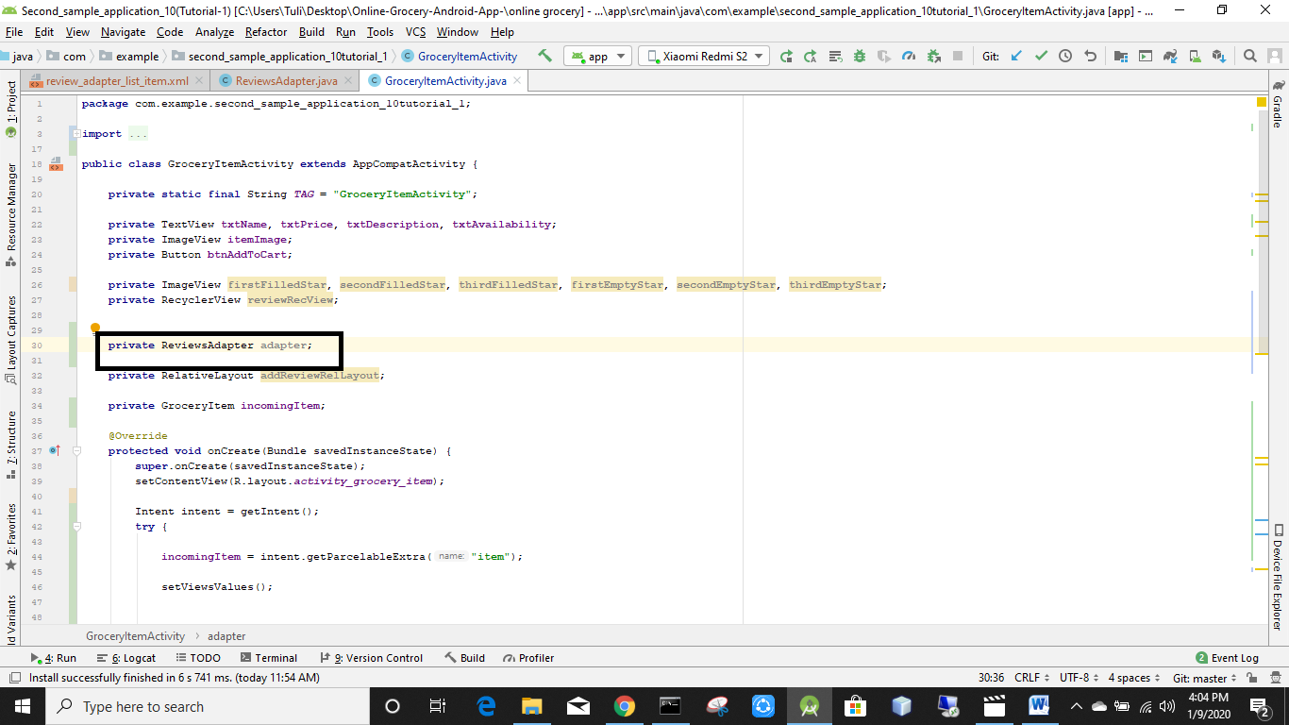

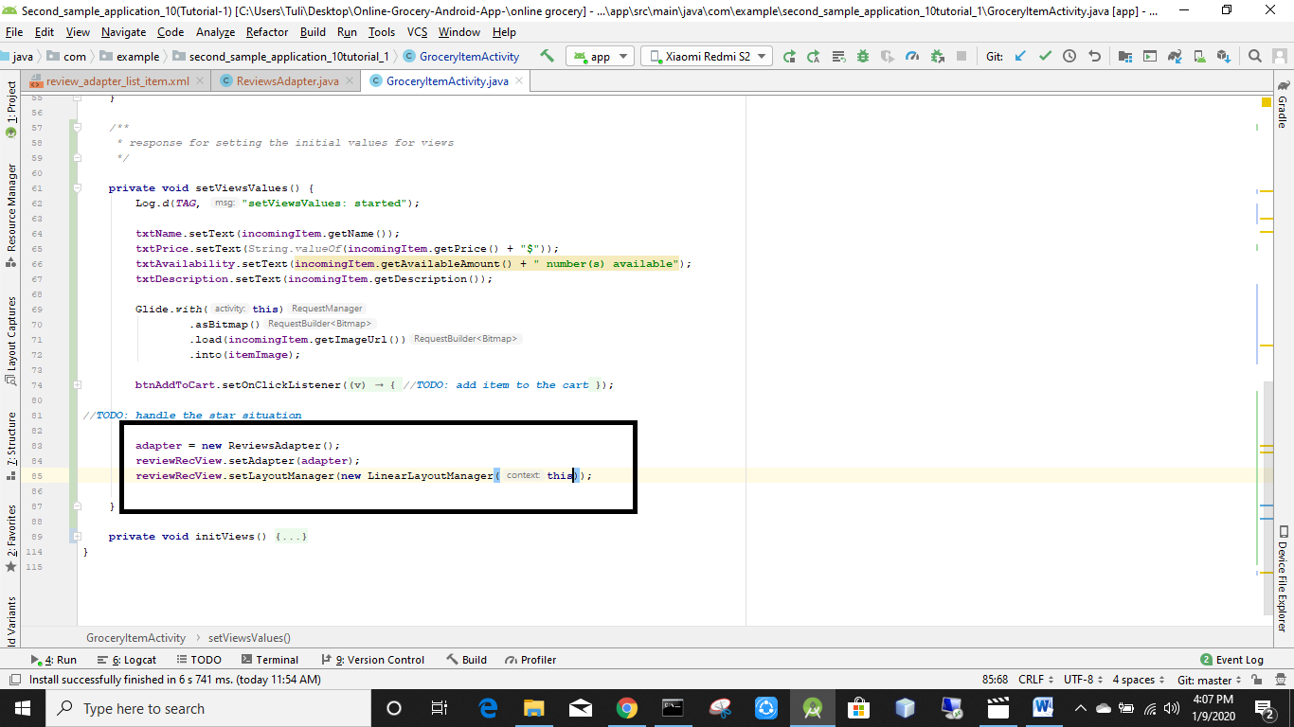

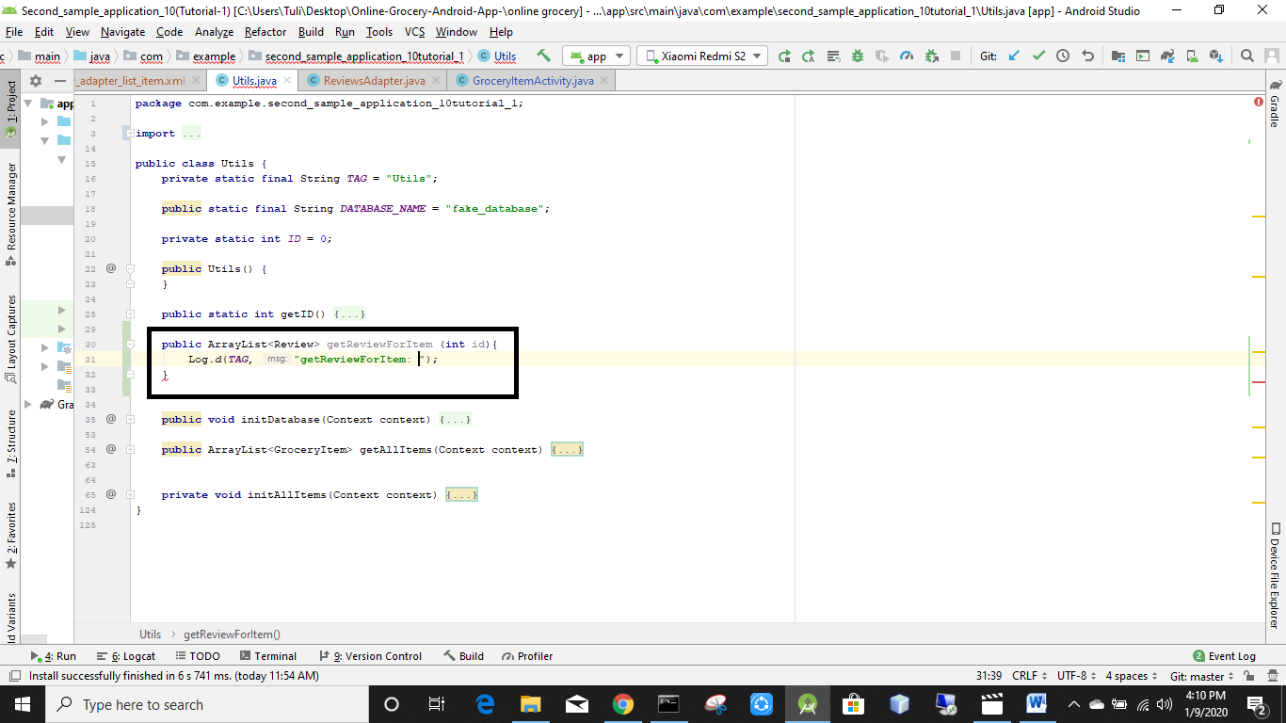

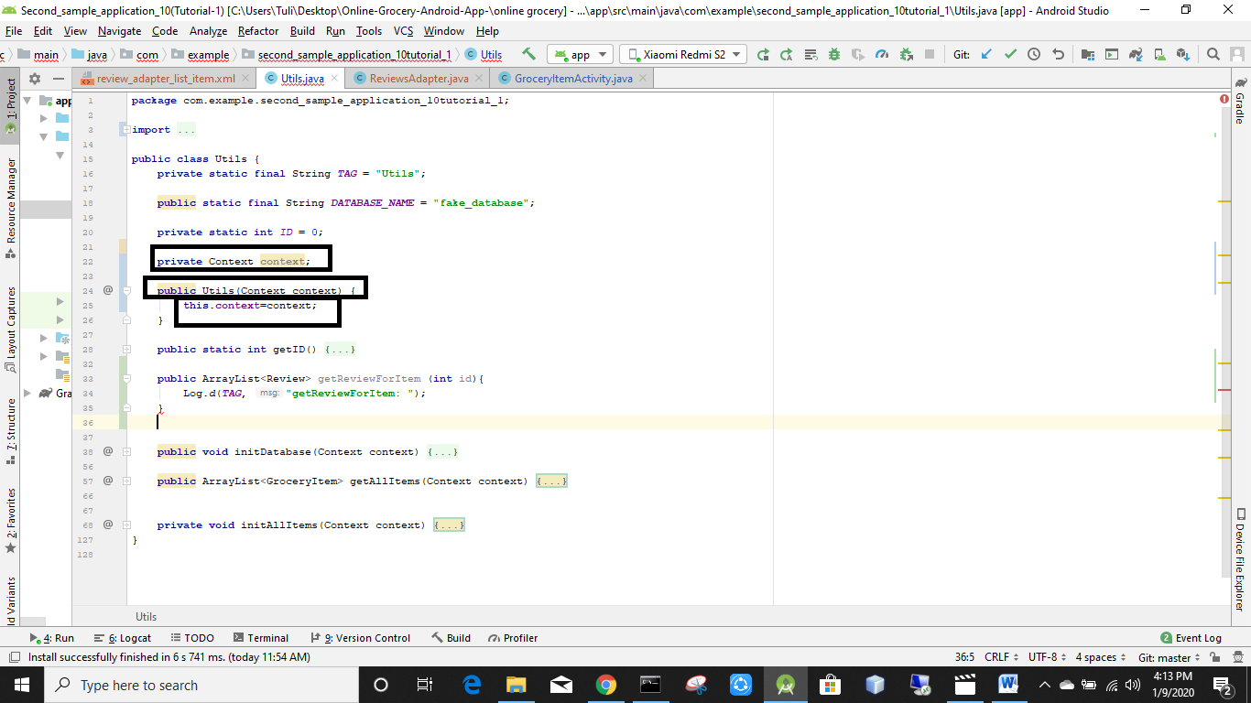

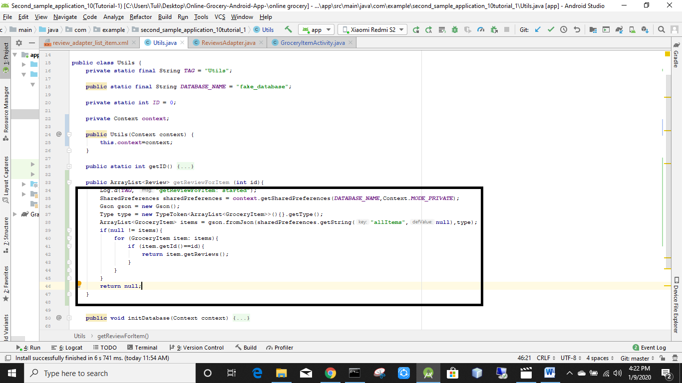

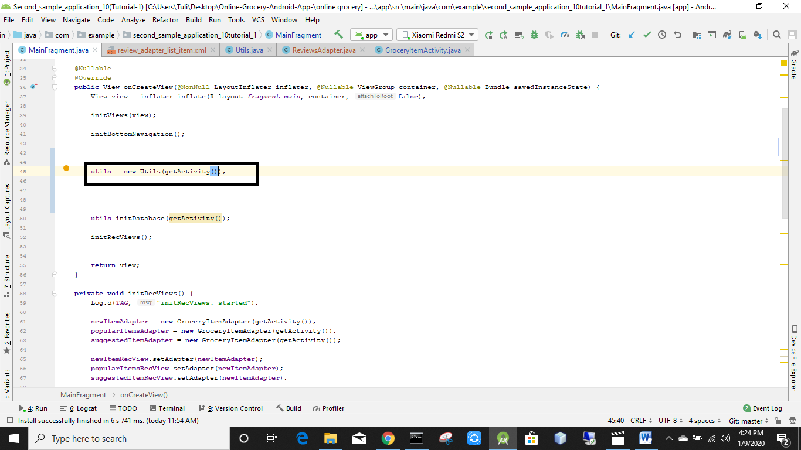

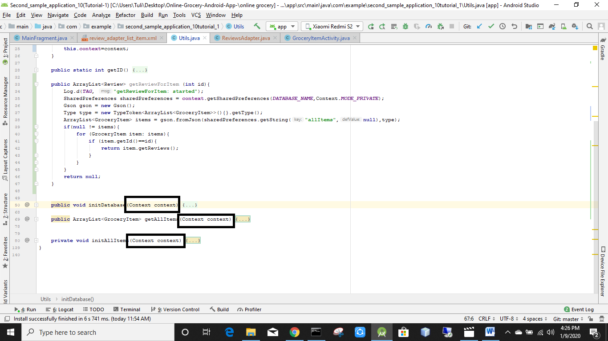

Mark kora lekha gulo delete korbo

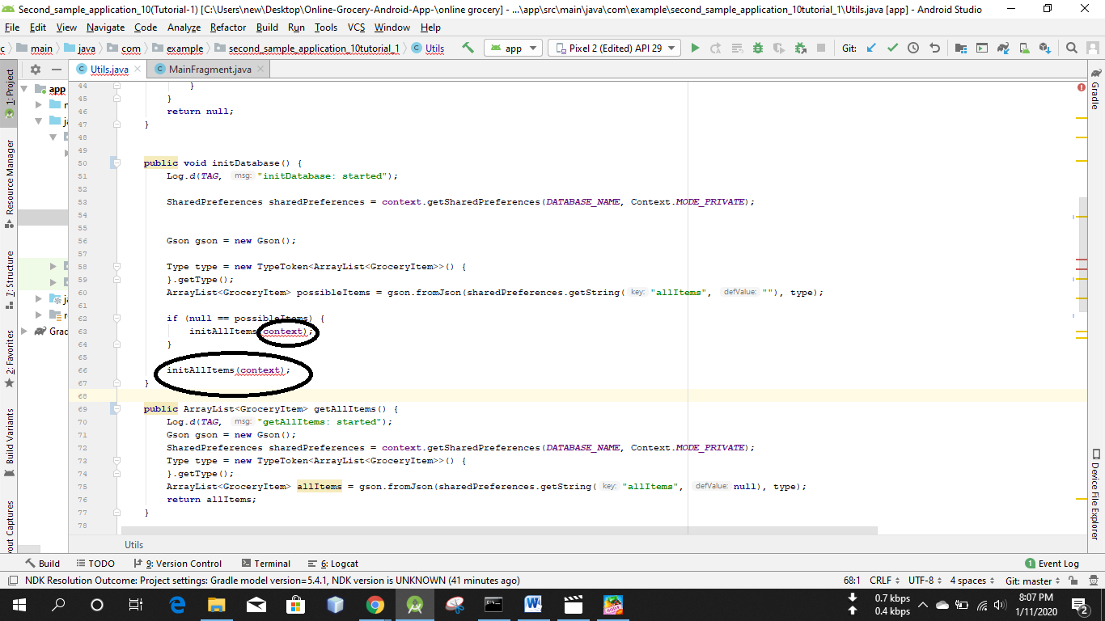

Mark kora ongsho gulo delete kore dibo

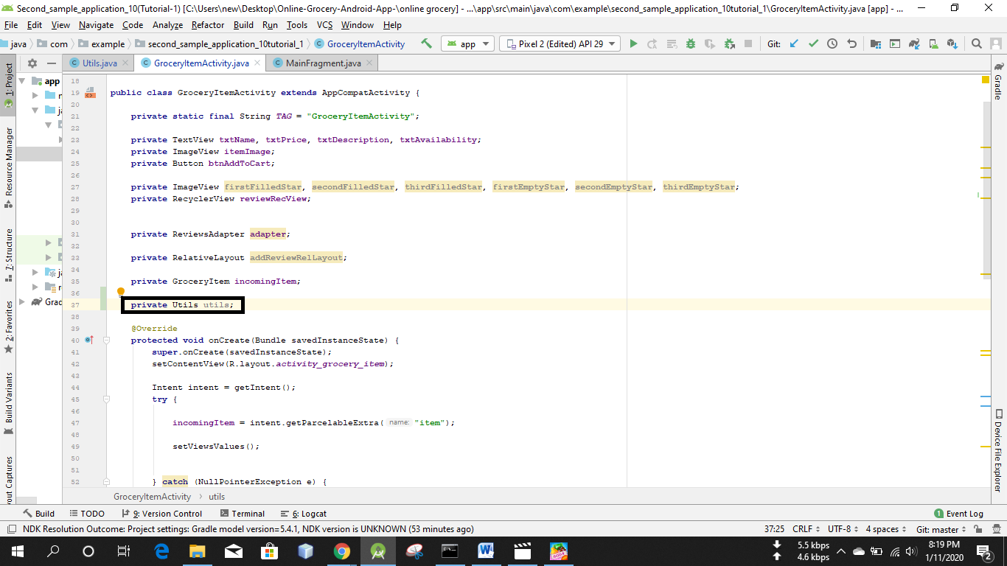

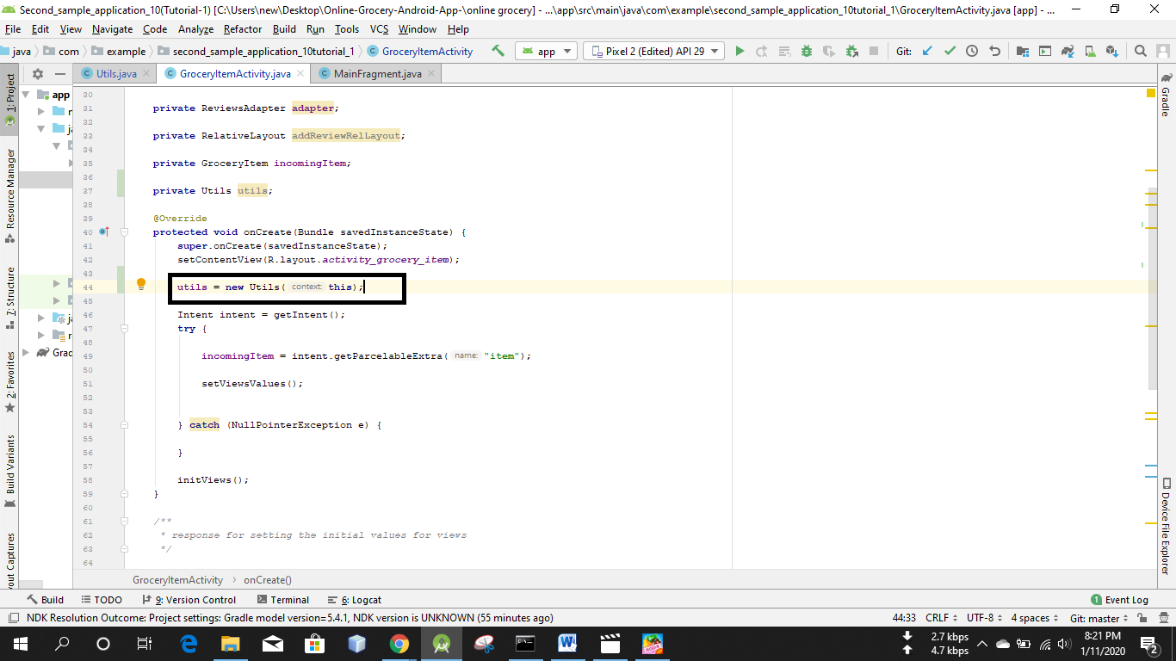

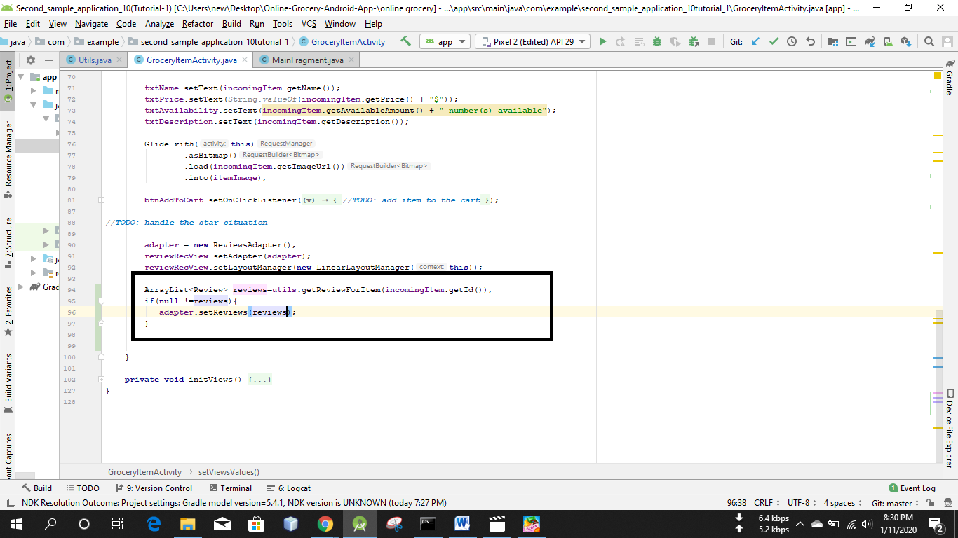

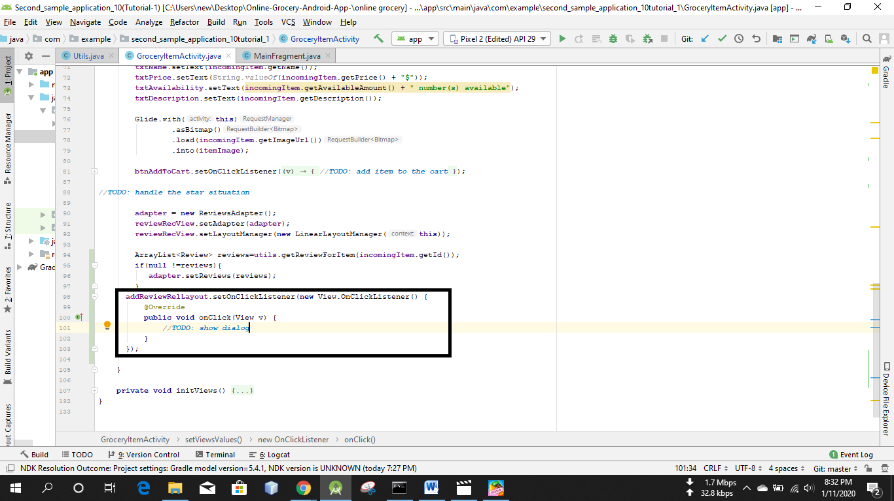

Layout er under e ekta layout resource file create korbo

Name it dialog_add_review

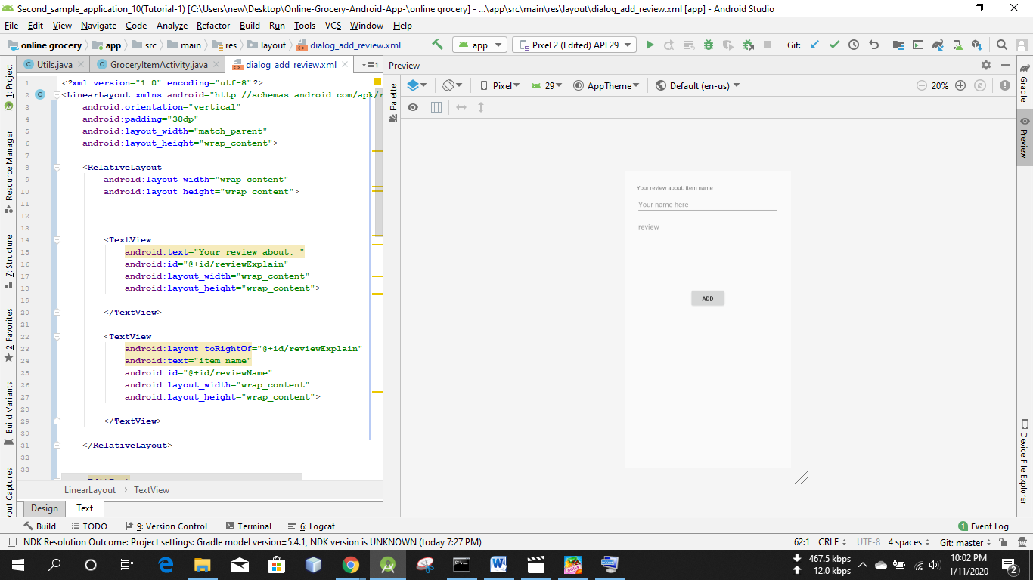

*<?***xml version="1.0" encoding="utf-8"***?>*<**LinearLayout xmlns:android="http://schemas.android.com/apk/res/android"  
 android:orientation="vertical"  
 android:padding="30dp"  
 android:layout_width="match_parent"  
 android:layout_height="wrap_content"**>  
  
 <**RelativeLayout  
 android:layout_width="wrap_content"  
 android:layout_height="wrap_content"**>  
  
  
  
 <**TextView  
 android:text="Your review about: "  
 android:id="@+id/reviewExplain"  
 android:layout_width="wrap_content"  
 android:layout_height="wrap_content"**>  
  
 </**TextView**>  
  
 <**TextView  
 android:layout_toRightOf="@+id/reviewExplain"  
 android:text="item name"  
 android:id="@+id/reviewName"  
 android:layout_width="wrap_content"  
 android:layout_height="wrap_content"**>  
  
 </**TextView**>  
  
 </**RelativeLayout**>  
  
  
 <**EditText  
 android:layout_marginTop="10dp"  
 android:hint="Your name here"  
 android:id="@+id/editTxtName"  
 android:layout_width="match_parent"  
 android:layout_height="wrap_content"**>  
  
 </**EditText**>  
  
 <**EditText  
 android:gravity="start"  
 android:lines="5"  
 android:layout_marginTop="10dp"  
 android:hint="review"  
 android:id="@+id/editTxtReview"  
 android:layout_width="match_parent"  
 android:layout_height="wrap_content"**>  
  
 </**EditText**>  
  
 <**TextView  
 android:layout_gravity="center"  
 android:layout_marginTop="10dp"  
 android:textColor="@color/colorAccent"  
 android:id="@+id/txtWarning"  
 android:layout_width="wrap_content"  
 android:layout_height="wrap_content"**>  
  
  
  
 </**TextView**>  
  
 <**Button  
 android:layout_marginTop="15dp"  
 android:layout_gravity="center"  
 android:text="add"  
 android:id="@+id/btnAdd"  
 android:layout_width="wrap_content"  
 android:layout_height="wrap_content"**>  
  
  
  
  
 </**Button**>  
  
  
  
  
</**LinearLayout**>

Java class nibo  
named it AddReviewDialog

